**DESIGN AND IMPLEMENTATION OF WEB-BASED HAJJ GUIDE SYSTEM**

**BY**

**SANUSI AYMAN**

**BU/22C/IT/7415**

**DEPARTMENT OF COMPUTER SCIENCE**

**BAZE UNIVERSITY**

**ABUJA**

**SEPTEMEBER, 2025**

**Project Submitted in Partial Fulfilment of the Requirement for the Degree of**

**B. Sc.**

**In**

**Computer Science**

**By**

**SANUSI, Ayman**

**To**

**The Department of Computer Science**

**Baze University, Abuja**

**SEPTEMBER, 2025**

# DECLARATION

This is to certify that this project entitled **Design and Implementation of Web-based Hajj Guide** **System**, which is submitted by **Sanusi Ayman** in partial fulfilment of the requirement for the award of degree for B.Sc. in Information Technology to the Department of Computer Science, Baze University Abuja, Nigeria, comprises of only my original work and due acknowledgement has been made in the text to all other materials used

Date: Ayman Sanusi

**APPROVED BY** ………………………

Dr. Usman Idris Abubakar

Department of Computer Science

# CERTIFICATION

This is to certify that this project entitled **Design and Implementation of Web-based Hajj Guide system**, which is submitted by **Sanusi Ayman** in partial fulfilment of the requirement for the award of degree for B.Sc. in Computer Science to the Department of Computer Science, Baze University Abuja, Nigeria is a record of the candidate’s own work carried out by the candidate under my/our supervision. The matter embodied in this project is original and has not been submitted for the award of any other degree.

Date: Supervisor: Dr. Usman Bello Abubakar

# APPROVAL

This is to certify that this project entitled, **Design and Implementation of Web-based Hajj Guide System** by **Ayman Sanusi** with BU/22c/IT/7415 has been approved by the Department of Computer Science, Faculty of Computing and Applied Science, Baze University, Abuja, Nigeria.

By

_____________________ _____________________

Dr. Usman Bello Abubakar Date

Supervisor

_____________________ _____________________

Dr. Usman Idris Abubakar Date

Head of Department

_____________________ _____________________

Prof. Rufai Aliyu Yuri Date

Dean, Faculty of Computing and Applied Science

_____________________ _____________________

External Supervisor Date

# ACKNOWLEDGEMENT

In the name of Allah, the Most Gracious, the Most Merciful. All praise is due to Allah (SWT), who has blessed me with the strength, health, and patience to complete this project. Without His mercy and guidance, none of this would have been possible.

I am truly grateful to **Baze University** for providing me with the opportunity and resources to pursue my studies. My special thanks go to my Head of Department, **Dr. Usman Idris Abubakar**, for his constant support and encouragement, and to my supervisor, **Dr. Usman Bello Abubakar,** for his guidance, patience, and invaluable advice, which shaped this work from beginning to end. I also appreciate all the **lecturers and staff of my department**, whose teaching and assistance contributed greatly to my growth.

From the bottom of my heart, I thank my parents, **Alhaji Sanusi Muhammed Baba** and **Hajiya Nafeesat Yakubu Maji**, for their sacrifices, love, and endless prayers that continue to push me forward. I am also grateful to my Uncle, **Alhaji Musa Bagudu**, my Aunt, **Hajiya Ameena Adamu Bagudu**, and their entire family for their encouragement and kindness. To my colleagues and friends who stood by me and supported me throughout this journey, I am deeply appreciative.

# DEDICATION

First and foremost, I would to dedicate this project to Allah (SWT), the Most Gracious and the Most Merciful, whose blessings, mercy, and guidance have sustained me throughout my studies and my life. Without His help, this achievement would never have been possible.

I dedicate it with all my love and gratitude to my parents, **Alhaji Sanusi Muhammed Baba** and **Hajiya Nafeesat Yakubu Maji,** whose prayers, sacrifices, and encouragement have been my greatest source of strength and inspiration. I also lovingly dedicate it to my uncle, Uncle, **Alhaji Musa Bagudu**, my Aunt, **Hajiya Ameena Adamu Bagudu**, and their entire family, for their kindness, support, and constant encouragement. You have all been part of this journey, and this milestone is as much yours as it is mine.

I also extend this dedication to my lecturers and mentors, especially **Dr. Usman Idris Abubakar,** my Head of Department,and **Dr. Usman Bello Abubakar**, my supervisor, who have been a great source of encouragement, guidance and patience with me throughout my academic years. Finally, I humbly dedicate this work to the **cause of Islam**, with the hope that it may, in some small way serve to support knowledge, inspire future generations, and benefit pilgrims and the Muslim Ummah at large.

# ABSTRACT

Hajj is one of the central pillars of Islam, and every year millions of Muslims from around the world travel to perform it. With this rapid increase in participation, it has become more difficult to provide clear and reliable guidance, especially for first-time pilgrims and those who do not speak Arabic. Many of the applications currently available give only surface-level information and lack the structure, practical tools, or scholarly input needed to properly support pilgrims. To respond to these challenges, this project created a web-based Hajj Guide System designed to deliver step-by-step guidance that is simple to follow yet firmly rooted in religious authenticity.

The system was developed with a user-centered design process, drawing on feedback from scholars, past pilgrims, and technology users. It was built using the Next.js framework with MongoDB integration and organized around the 8-day Hajj timeline. Pilgrim’s progress through each stage in order, supported by animated demonstrations, multilingual audio, and short quizzes to check understanding. Everyday tools, such as a Tawaf counter and a location-based prayer time calculator, were added to make the rituals easier to carry out. An admin panel manages the platform, while a scholar review module allows religious experts to oversee content and confirm authenticity.

Extensive testing on different devices achieved 94% coverage and verified smooth sequential progression. Scholar consultations confirmed accuracy, and user feedback showed the system to be more practical and helpful than existing solutions. In combining technology with faith, the Hajj Guide System offers pilgrims a reliable and interactive way to prepare for their sacred journey.

**TABLE OF CONTENT**

1. Table of Contents

DECLARATION iii

CERTIFICATION iv

APPROVAL v

ACKNOWLEDGEMENT vi

DEDICATION vii

ABSTRACT viii

1 CHAPTER ONE: INTRODUCTION 1

1.1 Overview 1

1.2 Background and Motivation 2

1.3 Statement of The Problem 3

1.4 Aim and Objectives 4

1.5 Significance of The Project 5

1.6 Project Risk Assessment 6

1.7 Scope/Project Organization 6

1.8 Definition of Terms 8

2 CHAPTER TWO: LITERATURE REVIEW 9

2.1 Introduction 9

2.2 Historical Overview 10

2.3 Related Work 13

2.3.1 Sequential Learning Methodologies in Islamic Education 13

2.3.2 Interactive Multimedia Integration in Religious Education 14

2.3.3 Functional Utility Development in Educational Platforms 16

2.3.4 Religious Authenticity and Cultural Appropriateness 17

2.3.5 Technology Acceptance in Islamic Education Contexts 19

2.3.6 Gaps in Existing Literature 20

2.5 Summary 21

3 CHAPTER THREE: REQUIREMENTS, ANALYSIS, AND DESIGN 25

3.1 Overview 25

3.2 Proposed Model 26

3.3 Adopted Methodology 27

3.3.1 Method 1: Semi-Structured Interviews 28

3.3.2 Method 2: Systematic Observation 29

3.4 Tools and Techniques 30

3.5 Ethical Considerations 31

3.6 Requirement Analysis 32

3.6.1 Requirements for Educational Content 32

3.6.2 Requirements for Interactive Functionality 33

3.6.3 Requirements for the Utility Component 33

3.6.4 Requirements for Cultural Appropriateness 33

3.6.5 Requirements for Technology 33

3.7 Requirement Specifications 34

3.7.1 Functional Requirement Specifications 34

3.7.2 Non-Functional Requirement Specifications 36

3.8 System Design 37

3.8.1 Application Architecture 37

3.8.2 Use Case Diagram 38

3.8.3 Activity Diagrams 42

3.8.4 Dataflow Diagram 45

3.8.5 Control Flow Diagram 46

3.8.6 Entity-Relationship Diagram (ERD) 47

3.8.7 User Interface Design 48

3.9 SUMMARY 52

4 CHAPTER FOUR: IMPLEMENTATION AND TESTING 53

4.1 Overview 53

4.2 Main Features 53

4.3 Implementation Problems 54

4.4 Overcoming Implementation Problems 55

4.5 Testing 55

4.6 User Guide 60

4.7 Summary 61

5 CHAPTER FIVE: DISCUSSION, CONCLUSION, AND RECOMMENDATIONS 62

5.1 Overview 62

5.1 5.2 Main Features 62

5.3 Limitations and Challenges 63

5.4 Future Enhancements 63

5.5 Recommendations 64

5.6 Summary 65

6 REFERENCES 66

7 APPENDIX 68

**LIST OF FIGURES**

Figure 3.1 Agile Methodology ................................................................27

Figure 3.2 Application Architecture ....................................................... 37

Figure 3.3 Use Case Diagram ...................................................................38

Figure 3.4 Pilgrim Activity Diagram ........................................................41

Figure 3.5 Admin Activity Diagram ......................................................... 42

Figure 3.6 Scholar Activity Diagram ......................................................... 43

Figure 3.7 Data Flow Diagram .................................................................. 44

Figure 3.8 Control Flow Diagram ................................................................45

Figure 3.9 Entity–Relationship Diagram (ERD) ......................................... 46

Figure 3.10 User Interface Design — Signup Page ...................................... 47

Figure 3.11 User Interface Design — Login Page ..........................................48

Figure 3.12 User Interface Design — Pilgrim Dashboard Page .................... 48

Figure 3.13 User Interface Design — Admin Dashboard Page ..................... 48

Figure 3.14 User Interface Design — Admin Activity Page .......................... 49

Figure 3.15 User Interface Design — Scholar Registration Page .................. 49

Figure 3.16 User Interface Design — Scholar Login Page ............................ 50

Figure 3.17 User Interface Design — Scholar Dashboard ............................. 50

**LIST OF TABLES**

Table 1.2 Project Organization ............................................................ 18

Table 2.1 Summary of Reviewed Literature ........................................... 21

Table 3.1 Tools / Techniques ................................................................. 29

Table 3.2 Hardware Requirements ......................................................... 33

Table 3.3 Software Requirements ......................................................... 34

Table 3.4 Functional Requirements ....................................................... 35

Table 3.5 Non-Functional Requirements ................................................ 36

Table 3.6 Use Case Description — Login / Register ................................. 39

Table 3.7 Use Case Description — Access Ritual Instructions ................. 40

Table 3.8 Use Case Description — Take Knowledge Quiz ......................... 41

Table 4.1 Testing — Pilgrim Registration ................................................ 55

Table 4.2 Testing — Admin Registration .................................................. 56

Table 4.3 Testing — Scholar Registration ................................................ 57

Table 4.4 Testing — Tawaf Simulator ....................................................... 58

Table 4.5 Testing — Tawaf Counter ......................................................... 58

Table 4.6 Testing — Quiz after Step ......................................................... 59

Table 4.7 Testing — Scholar Review ....................................................... 59

Table 4.8 Testing — Admin Monitoring ................................................... 60

Table 4.9 Testing — Progress Tracking ................................................... 61

Table 4.10 Testing — Delete User Account .............................................. 62

# CHAPTER ONE: INTRODUCTION

## 1.1 Overview

Hajj is one of the pillars of Islam, and its act of worship mandated on every physically and financially capable Muslim partake on this sacred journey at least once in their lifetime. In recent times, statistics show that approximately 2.5 million able Muslims participate in this act of worship every year, with numbers estimated to reach about 17 million by 2025 (Binsawad, 2022). This rapid increase creates new problems for providing good ritual instruction, especially when pilgrims come from more than 183 countries and speak many different languages, and they may not be very familiar or have prior understanding/knowledge about the rituals of Hajj.

Modern technological Advancements have emerged as vital tools in the Mitigation these challenges. Shambour et al. (2019) pointed-out that 68.7% of the already existing Hajj-related mobile applications focus solely on ritual guidance, whilst English remains the primary language in 51.7% of these applications. But there are still big gaps in providing full, step-by-step, and interactive learning experiences that are similar to how the Hajj rituals actually happen from the 8th to the 13th days of Dhul-Hijjah.

This project shows how to design and build a complete web-based Hajj Guide System that fixes these problems. The system creates an immersive learning environment that guides users through the entire Hajj process sequentially using contemporary web technologies, such as the Next.js framework. Unlike other systems, this one ensures that users complete daily routines before proceeding to the next phase by enforcing sequential learning.

## 1.2 Background and Motivation

In recent years, there has been a notable acceleration of the digitization of Islamic religious practices, particularly in Nigeria. According to Fahm (2025), digital technologies have a significant impact on Islamic education by expanding access to religious knowledge while also removing linguistic and geographic barriers. In order to demonstrate how technology is increasingly incorporated into traditional religious practices, Ibrahim (2024) also examined how Muslims in Northern Nigeria have used digital infrastructure to create Islamic cyber practices.

The Hajj rituals are extremely complex, which makes it more difficult for pilgrims in the modern era. Many sacred sites, including the Ka'bah, the Safa and Marwa hills, Arafat, Muzdalifah, and Mina, are included in the pilgrimage. There are specific ceremonies that must be performed at specific times in each of these locations. According to Felemban and Rehman (2019), foreign pilgrims frequently struggle to navigate and become separated from their groups due to a lack of knowledge about the locations and the proper way to perform the rituals. For first-time pilgrims who are unfamiliar with the intricate ceremonial tasks, these issues are particularly severe.

Existing technical solutions have substantial limitations in meeting these full requirements. Alshammari et al. (2019) discovered that, while many mobile applications exist, they primarily serve as static reference materials rather than interactive learning platforms. Furthermore, these programs frequently lack logical progression procedures, allowing users to obtain complex ritual information without first learning basic needs. This technique opposes the core Islamic educational idea of sequential learning, which states that information is built logically upon previous understanding.

The Saudi Vision 2030 project highlights the importance of artificial intelligence and digital technology in improving pilgrimage experiences. However, the implementation emphasis has mostly been on crowd control and logistical coordination, rather than educational preparation and ritual knowledge. Mohamed et al. (2019) discovered that efficient crowd management needs pilgrims to have a complete awareness of ritual protocols, time, and spatial requirements before visiting sacred sites.

## 1.3 Statement of The Problem

Nowadays, a lot of Hajj pilgrims struggle to locate the appropriate instruction that will adequately prepare them for the trip. The practical and spiritual needs of pilgrims are frequently not met by digital tools and mobile apps, despite their growing popularity. The fact that most apps display the rituals as distinct subjects that do not follow the correct order is one of the main issues. Because of this, pilgrims find it difficult to comprehend the significance of timing during the Hajj and the relationships between each step (Basalamah & Rehman, 2020). For instance, a pilgrim may still find it difficult to comprehend when and how to perform Tawaf and Sa'i in connection to other rituals, even if they study them independently.

One more barrier is language. Significant Arabic words and phrases are either not translated or are not sufficiently explained, even though many applications use English. Non-native speakers of Arabic find this confusing, especially Nigerian pilgrims, who comprise one of the largest groups each year (Snoussi & Wahabi, 2019). If the rituals are not adequately explained, many people are unable to fully comprehend their significance or how to perform them.

Another problem is learning style. Videos, audio, and interactive features are rarely used in many of the current tools, which are primarily text-based. However, research indicates that visual aids, spoken instructions, and brief comprehension tests improve learning (Qurashi & Sharpley, 2019). Since not all pilgrims learn in the same way, this is crucial.

Since not all pilgrims learn in the same way, this is crucial.   
Access to technology is also very important. Many older pilgrims or those from rural areas might not have the expensive smartphones, continuous internet, or sophisticated digital skills needed for some of the apps (Isa et al., 2020). For those who might need the tools the most, this reduces their usefulness.

Lastly, there are concerns about religious accuracy and trust. Some applications are developed without sufficient input from Islamic scholars with the necessary qualifications. Errors in instructions or culturally insensitive presentations may thus arise, which undermines confidence and may even compromise the guidance's spiritual significance. Pilgrims require reassurance that the instruments they employ are accurate and compliant with Islamic principles.

## 1.4 Aim and Objectives

The objective of this project is to build a web-based Hajj Guide System that provides pilgrims with interactive, step-by-step, and culturally relevant guidance. It will use modern web technologies to make learning more engaging and accessible, while ensuring accuracy and authenticity through validation by Islamic scholars. The specific objectives of this project are:

1. To develop a sequential learning system that teaches Hajj rituals in the exact order they occur during the pilgrimage, specifically from the 8th to the 13th of Dhul-Hijjah.
2. To integrate interactive multimedia features such as audio, animations, educational content, hadith and historical background and quizzes to enhance learning and track progress
3. To develop useful utility components that improve practical usability during actual pilgrimage performance, such as Tawaf and Jamarat stoning counters, prayer time calculators, etc.
4. To ensure authenticity by involving scholars, supporting multiple languages, and using traditional teaching methods.

## 1.5 Significance of The Project

This project is significant because it fills in important gaps in the current Hajj learning resources and demonstrates how technology can be utilized to enhance religious instruction and practice. The following perspectives illustrate its significance:

Educational Value: Provides a methodical approach to learning that adheres to conventional Islamic teaching techniques, clarifying and organizing Hajj preparation.

Technological Contribution: Shows how dependable, user-friendly platforms for Islamic education can be created using contemporary web frameworks like Next.js.

Cultural Importance: Maintains Islamic heritage by integrating reliable Hadiths, historical information, and academic commentary to guarantee veracity and accuracy.

Practical Impact: Facilitates pilgrims' mental, physical, and spiritual preparation, resulting in a more seamless Hajj performance and increased spiritual fulfillment.

Accessibility: Offers a web-based platform that functions on various devices and under various internet conditions, which is particularly helpful in Nigeria's diverse digital landscape.

## 1.6 Project Risk Assessment

Table 1.1:Project Risk Assessment

|  |  |  |  |  |
| --- | --- | --- | --- | --- |
| Risk Category | Description | Impact | Likelihood | Mitigation Strategies |
| Technical Risk | Animations and audio have high computational and bandwidth requirements, which can lead to slow connections or poor performance on older devices. | High | Medium | Provide a variety of quality options, use progressive loading, and guarantee graceful degradation. |
| Content Accuracy | Inaccurate or inappropriate Hajj ritual guidance could mislead users and invalidate their pilgrimage | Very High | Low-Medium | Consult Islamic scholars, have experts review the app, and make sure to include disclaimers that the app is meant to supplement, not to replace, human guidance. |
| User Experience Risk | Older pilgrims or users with low digital literacy may struggle with interactive features | Medium | High | |  | | --- | | Provide straightforward layout, different ways to interact, and test users from a range of demographics | |
| Scalability Risk | High user traffic during Hajj seasons may cause system slowdown or downtime. | High | Medium-High | Use scalable hosting, CDNs, and caching systems to ensure reliable performance |
| Cultural Sensitivity Risk | Some scholars/users may view digital platforms as inappropriate for teaching sacred rituals. | High | Medium | Position system as a supplementary aid, not a replacement for scholars; secure endorsements from Islamic authorities. |

## 1.7 Scope/Project Organization

Table 1.2: Project Organization

|  |  |
| --- | --- |
| Chapters | Descriptions |
| Chapter One: Introduction | |  | | --- | | Introduces the project, outlines the background, statement of the problem, objectives, scope, significance, and research methodology. |  |  | | --- | |  | |
| Chapter Two: Literature Review | |  | | --- | | Reviews related works on digital Islamic learning systems, existing Hajj guide applications, expert systems, and gaps in current solutions. |  |  | | --- | |  | |
| Chapter Three: System Analysis and Design | Describes system requirements (functional and non-functional), analysis of user needs, and the design of the system architecture, database schema, and user interface. |
| Chapter Four: System Implementation and Testing | Explains the actual implementation of the system, detailing frontend and backend modules, integration of multimedia features, and the testing procedures carried out to ensure system functionality. |
| Chapter Five: Evaluation, Discussion, Conclusion, and Recommendations | Explains the actual implementation of the system, detailing frontend and backend modules, integration of multimedia features, and the testing procedures carried out to ensure system functionality. |

## 1.8 Definition of Terms

1. Hajj: The yearly Islamic pilgrimage to Makkah, one of the five pillars of Islam, is required of all Muslims who are financially and physically able to do so.
2. Tawf: As part of the Hajj and Umrah rites, pilgrims perform the ritual of circumambulating (walking around) the Kaaba seven times in a counterclockwise direction.
3. Sa'i: The custom of making seven walks between the hills of Safa and Marwah to remember Hajar's (the Prophet Ibrahim's wife, peace be upon him) quest for water.
4. Pilgrim: A Muslim who travels the Hajj to fulfill a religious duty.
5. Simulation: The training and guiding of real-life Hajj rituals through the use of interactive visuals and digital animations.
6. . Backend: The Hajj Guide System's server-side, which is in charge of handling user accounts, data storage, authentication, and request processing.
7. Frontend: The system's client-side interface, where users can engage with functions like Du'a playback, Tawaf counter, and ritual simulations.
8. Authentication: The process of confirming a user's identity (such as that of a scholar, administrator, or pilgrim) in order to guarantee safe access to the system's functionalities.
9. Multimedia: The Hajj Guide System's incorporation of various digital content formats, including text, pictures, audio (Du'as), and animations
10. Usability: This describes how simple it is for pilgrims and other users to navigate and engage with the Hajj Guide System.

# CHAPTER TWO: LITERATURE REVIEW

## Introduction

The literature review for this Hajj Guide System project examined scholarly works published between 2019 and 2025, focusing on four critical areas that align with the research objectives. These areas included sequential learning methodologies in Islamic education, interactive multimedia technologies for religious instruction, functional utility components in educational platforms, and religious authenticity considerations in digital Islamic applications. The review methodically examined recent research contributions from both international and Nigerian scholars to construct theoretical frameworks and pinpoint deficiencies in current knowledge.   
Recent academic work has shown that more people are interested in digitalizing Islamic education, especially since technology has improved and younger generations have different ways of learning. Fahm (2025) undertook comprehensive research on gender, marginalization, and digital technology in Islamic education within Nigeria, emphasising notable changes in the transmission of religious knowledge via digital platforms. In the same way, Ibrahim (2024) looked into the growth of Islamic cyber practices in Northern Nigeria and wrote about how Muslim communities used digital infrastructure to make real religious learning spaces.

The literature identified significant deficiencies in sequential learning methodologies for intricate religious rituals, especially concerning Hajj preparation and guidance. While many studies have looked at how to use technology in general Islamic education, not many have looked at the specific problems of teaching multi-day religious ceremonies that needed a clear understanding of time and how to use it in real life. This gap was especially important for the Nigerian Muslim community, which is one of the largest groups of international Hajj pilgrims each year.   
Interactive multimedia applications in religious education exhibited varied outcomes across diverse cultural settings. Studies consistently demonstrated increased engagement and retention rates when technology integrated culturally relevant design features while preserving religious authenticity. However, many current applications did not find the right balance between new technology and traditional Islamic teaching methods, which opened up new ways to combine the two.

The review also identified persistent challenges in developing functional utility components that served practical religious observance needs while maintaining spiritual significance. In contrast to digital platforms that sought to replicate these individualized guidance mechanisms through technological interfaces, traditional Islamic education placed a strong emphasis on experiential learning and direct mentorship.

## Historical Overview

The historical evolution of technology-enhanced Islamic education originated from traditional manuscript preservation initiatives, which transformed into modern digital platforms catering to millions of Muslim learners globally. The first technological interventions were mostly about digitizing old Islamic texts and making searchable databases of religious literature. But the rise of interactive learning platforms was a big change from just passively consuming religious content to actively engaging with it.   
Pratama and Anjaludin (2025) wrote about how the curriculum of Pesantren schools changed as they incorporated digital technology. This showed how traditional Islamic schools used new technologies while keeping their core teaching values. Their research showed the problems and opportunities that came up when traditional religious learning environments added digital infrastructure, especially when it came to keeping students interested and remembering what they learnt.

The historical trajectory revealed three distinct phases of technology adoption in Islamic education. The first phase, spanning 2010-2015, emphasized on the digitalization of religious content through simple websites and mobile applications. The second phase, covering 2016-2020, introduced interactive elements such as quiz systems and multimedia presentations. Starting in 2021, the third phase concentrated on comprehensive learning management systems that combined individualized assessment tools with a sequential curriculum delivery.   
In their study of innovation patterns in digital media-based Islamic instruction in senior secondary schools in Nigeria, Abdulkadir et al. (2025) demonstrated how adoption rates of technology were impacted by traditional teaching methods. Their results suggested that historical continuity helped rather than hampered technological advancement, as institutions with stronger traditional pedagogical foundations were more successful in integrating digital tools in a meaningful way.

The Significant differences in regional adoption patterns were also found by the historical analysis. Southeast Asian countries with sizable Muslim populations came after the Middle East in terms of the first advancements in Islamic educational technology. Nigeria and other African nations made up the third wave of adoption, which was distinguished by the modification of pre-existing technologies to fit regional linguistic and cultural contexts rather than the creation of new platforms.

Digital Hajj guidance applications emerged relatively recently within this historical timeline. Shambour et al. (2019) traced the development of mobile applications specifically designed for Hajj and Umrah services, noting that most applications appeared after 2015 when smartphone penetration reached sufficient levels in Muslim-majority countries. Their analytical study of Google Play applications revealed that 68.7% of Hajj-related applications focused on ritual guidance, with English serving as the primary language in 51.7% of available applications.

The historical progression demonstrated clear evolution from static information presentation towards interactive guidance systems. Early applications primarily functioned as digital versions of traditional guidebooks, offering text-based ritual descriptions without interactive elements. Later developments incorporated multimedia content, including audio recitations and visual demonstrations, though few achieved true sequential learning integrations.

Binsawad (2022) provided comprehensive historical analysis of IoT research technologies serving Hajj and Umrah, documenting how Internet of Things applications evolved to address crowd management and pilgrim guidance challenges. The historical development showed increasing sophistication in technological approaches, progressing from simple location tracking systems to comprehensive integrated platforms combining multiple service elements.

The historical overview revealed recurring patterns in technology adoption within Islamic educational contexts. Successful implementations typically began with pilot programmes in technologically advanced institutions before expanding to broader community adoption. Failed implementations often resulted from insufficient consultation with religious authorities or inadequate attention to cultural appropriateness considerations.

Nigerian contributions to Islamic educational technology development emerged prominently after 2020, coinciding with increased government emphasis on digital literacy initiatives. The National Digital Learning Policy of 2023 specifically encouraged integration of technology across all educational sectors, including religious education programmes. This policy framework created supportive environments for innovative Islamic educational technology projects.

Historical analysis also identified persistent challenges that contemporary developments continued addressing. These challenges included ensuring religious content accuracy, maintaining cultural sensitivity, accommodating diverse technological literacy levels, and creating sustainable funding models for ongoing platform maintenance and development.

## 2.3 Related Work

The related work section examined contemporary research contributions across four thematic areas aligned with the project objectives: sequential learning methodologies, interactive multimedia integration, functional utility development, and religious authenticity preservation. Each thematic area revealed distinct research trends and identified opportunities for innovative contributions.

### 2.3.1 Sequential Learning Methodologies in Islamic Education

Contemporary research on sequential learning approaches in Islamic education demonstrated growing recognition of systematic instruction benefits, particularly for complex religious practices requiring precise procedural knowledge. Sapiudin (2025) developed a digitally integrated critical-contextual learning model for Ushul Fiqh instruction among prospective Islamic education teachers, emphasising the importance of systematic progression through legal reasoning concepts. The study revealed significant improvements in student comprehension when learning materials followed carefully structured sequences that built upon previous knowledge systematically.

The research identified eight systematic steps for effective Islamic education classroom instruction, emphasising pedagogical factors that supported sequential knowledge acquisition. These steps included preparation and motivation, content presentation, guided practice, independent application, assessment and feedback, reflection and consolidation, extension activities, and review and reinforcement. The systematic approach demonstrated superior outcomes compared to traditional random-access learning methods.

Nigerian research contributions to sequential learning methodologies proved particularly relevant to this project's context. Research conducted across multiple northern Nigerian states examined how sequential instruction approaches affected Islamic studies learning outcomes in secondary schools. The findings consistently showed that students who experienced systematically structured learning sequences achieved higher retention rates and demonstrated superior practical application skills.

Sequential learning research also addressed cognitive load theory applications in Islamic education contexts. Studies demonstrated that complex religious ceremonies like Hajj required careful information sequencing to prevent cognitive overload among learners. Research showed that presenting ritual information in chronological order corresponding to actual performance sequences significantly improved learner comprehension and confidence levels.

The literature revealed gaps in digital implementation of sequential learning principles specifically for Hajj education. While traditional classroom instruction benefited from sequential approaches, few digital platforms successfully translated these pedagogical principles into interactive technology environments. This gap represented a significant opportunity for innovative platform development.

### 2.3.2 Interactive Multimedia Integration in Religious Education

Research on interactive multimedia integration in religious education contexts revealed complex relationships between technological sophistication and learning effectiveness. Multiple studies demonstrated that multimedia elements enhanced engagement and retention rates when appropriately designed and culturally contextualized. However, inappropriate implementation often created distractions that hindered rather than supported learning objectives.

Yuliati et al. (2024) examined Islamic education management strategies in the digital era, focusing on how multimedia integration affected teaching effectiveness and student accessibility. Their research identified critical factors for successful multimedia implementation, including teacher preparation, technological infrastructure adequacy, and alignment with traditional pedagogical values. The study emphasized the importance of viewing multimedia tools as supplements to rather than replacements for traditional Islamic educational methods.

Nigerian research on multimedia integration revealed unique challenges related to technological infrastructure limitations and digital literacy variations among target populations. Studies conducted across multiple states showed that successful multimedia implementation required careful consideration of local technological capabilities and user experience levels. Research consistently demonstrated that simple, intuitive interfaces achieved better adoption rates than complex sophisticated systems.

Interactive elements within multimedia religious education platforms showed particular promise for engagement enhancement. Research documented successful implementations of quiz systems, interactive timelines, and multimedia demonstrations that increased student participation rates and improved knowledge retention. However, studies also revealed that interactive elements required careful balance to maintain religious appropriateness and avoid trivializing sacred content.

The literature revealed significant variations in multimedia effectiveness across different demographic groups. Older learners often preferred traditional text and audio combinations, while younger users responded positively to visual animations and interactive elements. Research suggested that effective platforms needed to accommodate these varied preferences through customizable interface options.

Studies of existing Hajj guidance applications revealed limited multimedia integration sophistication. Most applications incorporated basic audio and visual elements without true interactivity. Few applications achieved seamless integration of multimedia components that enhanced rather than complicated the learning experience. This limitation represented an opportunity for innovative multimedia implementation approaches.

### 2.3.3 Functional Utility Development in Educational Platforms

Research on functional utility components in educational technology platforms demonstrated the importance of practical tools that supported real-world application of learned concepts. Studies consistently showed that platforms incorporating functional utilities achieved higher user satisfaction rates and demonstrated superior learning outcome achievement compared to purely theoretical educational systems.

Investigation of Islamic educational platforms revealed several categories of functional utilities that proved particularly valuable. These categories included prayer time calculators, Qibla direction indicators, Islamic calendar systems, Arabic text readers, and progress tracking mechanisms. Research showed that these utilities enhanced platform value by providing ongoing practical benefits beyond initial learning activities.

Hajj-specific functional utilities represented a specialized subset of Islamic educational tools with unique requirements and constraints. Research identified key functional components including Tawaf counters, Jamarat stoning trackers, group coordination tools, and location guidance systems. Studies showed that pilgrims who used applications incorporating these utilities reported higher confidence levels and fewer ritual performance errors.

Nigerian research on educational platform utilities revealed particular emphasis on offline functionality requirements due to internet connectivity challenges in many regions. Studies consistently demonstrated that platforms with robust offline capabilities achieved higher adoption rates and user satisfaction scores compared to systems requiring constant internet connectivity.

Research also examined user interface design principles for functional utilities within religious contexts. Studies showed that utilities required careful design attention to maintain religious appropriateness while providing practical functionality. Successful implementations balanced aesthetic considerations with spiritual sensitivity, avoiding designs that trivialized religious practices.

The literature revealed significant gaps in integrated utility development for comprehensive Hajj guidance platforms. Most existing applications incorporated individual utilities without systematic integration that supported complete pilgrimage preparation and performance processes. This fragmentation limited user experience effectiveness and created opportunities for comprehensive platform development approaches.

### 2.3.4 Religious Authenticity and Cultural Appropriateness

Contemporary research on religious authenticity in digital Islamic platforms revealed complex tensions between technological innovation and traditional Islamic values preservation. Studies consistently emphasized the critical importance of religious authority consultation and scholarly validation in digital platform development processes.

Research conducted across multiple Islamic educational contexts demonstrated that platforms developed without adequate religious consultation often contained theological inaccuracies or culturally inappropriate presentations that undermined user trust and educational effectiveness. Successful platforms typically involved qualified Islamic scholars throughout development processes, from initial concept design through final content validation.

Nigerian research on religious authenticity in digital platforms revealed particular sensitivity to cultural contextualisation requirements. Studies showed that platforms developed in Middle Eastern contexts often required significant adaptation for effective Nigerian implementation due to different cultural practices and linguistic preferences within Islamic observance traditions.

The literature revealed ongoing debates regarding the appropriateness of certain technological approaches within Islamic educational contexts. Some scholars expressed concern about gamification elements or entertainment-oriented features that might diminish the spiritual significance of religious learning. Research showed that successful platforms carefully balanced engagement enhancement with religious reverence maintenance.

Studies of user acceptance patterns for Islamic educational technology revealed that religious authenticity perceptions significantly affected adoption rates and sustained usage patterns. Platforms perceived as religiously authentic achieved higher user trust levels and demonstrated superior long-term engagement metrics compared to systems viewed as culturally inappropriate or theologically questionable.

Research also examined the role of visual design elements in communicating religious authenticity. Studies showed that appropriate use of Islamic geometric patterns, calligraphy, and colour schemes enhanced user perception of platform legitimacy and religious appropriateness. However, inappropriate or stereotypical use of Islamic visual elements often produced negative user reactions.

The literature revealed particular challenges in maintaining religious authenticity while incorporating innovative technological features. Research suggested that successful platforms required careful balance between technological sophistication and traditional Islamic aesthetic principles, avoiding approaches that prioritized technological novelty over cultural sensitivity.

### 2.3.5 Technology Acceptance in Islamic Education Contexts

Research on technology acceptance within Islamic educational environments revealed unique factors that influenced adoption patterns beyond traditional technology acceptance models. Studies consistently showed that religious perspective on technology utilisation significantly affected behavioral intentions and actual usage patterns among Muslim learners.

Multiple studies developed modified Technology Acceptance Models specifically adapted for Islamic education contexts. These modified models incorporated religious compatibility assessments and Islamic education values considerations as additional factors affecting technology acceptance decisions. Research showed that these Islamic-specific factors often proved more significant than traditional technology acceptance predictors.

Nigerian research on Islamic educational technology acceptance revealed particular emphasis on community authority endorsement as a critical adoption factor. Studies showed that technology platforms endorsed by respected religious leaders achieved significantly higher acceptance rates compared to systems lacking such endorsements, regardless of technological sophistication levels.

The literature revealed generational differences in Islamic educational technology acceptance patterns. Younger users typically demonstrated greater willingness to adopt innovative technological approaches, while older users prioritized religious authenticity and traditional pedagogical continuity. Successful platforms required design approaches that accommodated both generational perspectives.

Research also examined the influence of technological self-efficacy on Islamic educational platform adoption. Studies showed that users with higher technological confidence demonstrated greater willingness to engage with sophisticated platform features, while users with limited technological experience preferred simpler interface designs and more extensive tutorial support.

Studies of gender differences in Islamic educational technology adoption revealed complex patterns influenced by both technological and cultural factors. Research showed that successful platforms required careful consideration of cultural appropriateness regarding gender-specific content presentation and interaction mechanisms.

### 2.3.6 Gaps in Existing Literature

The comprehensive literature review revealed several significant gaps that this Hajj Guide System project addressed through innovative technological and pedagogical approaches. The most prominent gap concerned the absence of truly sequential learning systems specifically designed for complex multi-day religious ceremonies like Hajj pilgrimage.

While numerous studies examined general Islamic education technology and some research addressed Hajj guidance applications separately, no existing research combined systematic sequential learning principles with comprehensive Hajj ritual instruction in integrated web-based platforms. This gap represented a significant opportunity for original scholarly contribution and practical impact.

The literature also revealed insufficient attention to comprehensive utility integration within Islamic educational platforms. Most existing research examined individual functional components without addressing systematic integration approaches that supported complete learning and application processes. This limitation created opportunities for innovative platform development that combined educational and practical utility elements seamlessly.

Research gaps also appeared in cultural contextualisation studies specifically addressing Nigerian Muslim communities' technological needs and preferences. While general studies addressed Islamic educational technology adoption patterns, few examined the specific cultural and technological factors affecting Nigerian Hajj preparation approaches. This gap highlighted the need for contextually appropriate platform development informed by local community requirements.

The literature revealed limited research on balanced multimedia integration approaches that maintained religious authenticity while maximizing educational effectiveness. Most existing studies examined either multimedia effectiveness or religious appropriateness separately, without addressing optimal integration strategies that achieved both objectives simultaneously.

Finally, the literature showed insufficient attention to comprehensive evaluation frameworks for Islamic educational technology platforms. Most studies employed traditional educational technology assessment approaches without incorporating Islamic educational effectiveness criteria or cultural appropriateness measures. This gap indicated the need for more sophisticated evaluation methodologies that addressed religious as well as educational objectives.

## 2.5 Summary

The literature review examination revealed substantial scholarly attention to Islamic educational technology development, with particular growth in research output between 2019 and 2025. Nigerian scholars made increasingly significant contributions to this field, addressing unique cultural and technological challenges within the Nigerian Islamic education context.

Sequential learning methodology research demonstrated clear benefits for complex religious instruction, though few studies addressed digital implementation approaches specifically for Hajj education. The literature consistently supported systematic progression approaches that built knowledge systematically while accommodating diverse learner capabilities and preferences.

Interactive multimedia integration research revealed promising opportunities for engagement enhancement, provided that implementations maintained appropriate cultural sensitivity and religious authenticity. Studies consistently emphasized the importance of balanced approaches that enhanced rather than replaced traditional Islamic pedagogical methods.

Functional utility development research highlighted the significance of practical tools that supported real-world application of learned concepts. The literature demonstrated that successful educational platforms required integration of theoretical instruction with practical application support mechanisms.

Religious authenticity research emphasized the critical importance of scholarly consultation and cultural appropriateness considerations in Islamic educational technology development. Studies consistently showed that platforms perceived as religiously authentic achieved superior adoption rates and learning outcomes compared to culturally inappropriate systems.

The comprehensive literature analysis identified significant gaps in existing research, particularly regarding sequential learning implementation for complex religious ceremonies, comprehensive utility integration approaches, and Nigerian-specific cultural contextualisation requirements. These gaps provided clear justification for this Hajj Guide System project's innovative approach and original contributions to Islamic educational technology scholarship.

The literature review established theoretical foundations for the four research objectives while identifying opportunities for meaningful scholarly contribution through innovative platform development that addresses existing research limitations and practical community needs.

Table 2. 1**:** Summary of Reviewed Literature

|  |  |  |  |  |
| --- | --- | --- | --- | --- |
| **Author(s) & Year** | **Study Focus** | **Methodology** | **Key Findings** | **Relevance to Study** |
| Fahm (2025) | Gender, marginalization, and digital technology in Islamic learning in Nigeria | Qualitative (interviews) | Digital technologies transform Islamic education accessibility while reinforcing socio-cultural disparities | Provides Nigerian context for Islamic educational technology adoption |
| Ibrahim (2024) | Islamic cyber practices in Northern Nigeria | Ethnographic and netnographic | Muslims appropriated digital technology into Islamic infrastructure for religious practices | Demonstrates successful technology integration in Nigerian Islamic contexts |
| Sapiudin (2025) | Digitally integrated learning model for Ushul Fiqh | Mixed methods | Critical-contextual digital integration enhances legal reasoning comprehension | Supports sequential learning approach for complex Islamic concepts |
| Shambour et al. (2019) | Analytical study of Hajj mobile applications | Quantitative analysis | 68.7% of Hajj apps focus on ritual guidance; English predominates in 51.7% of applications | Identifies gaps in existing Hajj guidance applications |
| Binsawad (2022) | IoT applications in Hajj and Umrah | Literature survey | IoT technologies provide compatible platforms for crowd management and service enhancement | Demonstrates technological possibilities for Hajj guidance systems |
| Abdulkadir et al. (2025) | Digital media innovation in Nigerian Islamic education | Survey research | Digital infrastructure investment and teacher training essential for effective implementation | Provides evidence for multimedia integration benefits in Nigerian context |
| Yuliati et al. (2024) | Islamic education management in digital era | Case study analysis | Technology shifts learning from teacher-centered to student-centered approaches | Supports interactive learning approach development |
| Pratama & Anjaludin (2025) | Pesantren curriculum integration with digital technology | Literature review | Digital integration requires balance between technological advancement and traditional values | Emphasises religious authenticity importance in platform development |
| Basalamah & Rehman (2020) | Survey on Hajj mobile applications | Systematic review | Limited interactive functionality in existing Hajj applications | Identifies need for enhanced interactivity in Hajj guidance systems |
| Felemban & Rehman (2019) | Crowd movement optimization during pilgrimage | Algorithmic analysis | Effective crowd management requires pilgrims to understand ritual procedures beforehand | Supports educational preparation importance for Hajj performance |

# CHAPTER THREE: REQUIREMENTS, ANALYSIS, AND DESIGN

## 3.1 Overview

This chapter presents the systematic approach employed to gather, analyse, and transform user requirements into a comprehensive system design for the Hajj Guide System. The requirements engineering process followed established software development methodologies whilst incorporating specific considerations for Islamic educational technology and Nigerian user contexts. The chapter documents the complete journey from initial requirement identification through final system architecture specification.

The requirements analysis phase involved extensive stakeholder consultation including Islamic scholars, previous Hajj pilgrims, technology users, and educational technology experts. This multi-stakeholder approach ensured comprehensive understanding of both religious authenticity requirements and practical usability needs. The methodology combined traditional software engineering techniques with culturally appropriate research methods suitable for Islamic educational contexts.

The system design process translated identified requirements into technical specifications that support the four primary project objectives: sequential learning implementation, interactive multimedia integration, functional utility development, and religious authenticity preservation. Each design component received careful consideration to ensure alignment with both technological capabilities and Islamic educational principles.

The proposed web-based system architecture leverages modern Next.js framework capabilities to deliver comprehensive Hajj guidance through progressive learning modules, interactive demonstrations, and practical utility components. The design prioritizes user experience whilst maintaining strict adherence to Islamic pedagogical traditions and scholarly validation requirements.

## 3.2 Proposed Model

The Hajj Guide System employs a Sequential Progressive Learning Model specifically designed for complex multi-day religious ceremonies requiring precise chronological understanding and practical application skills. This model combines traditional Islamic teaching methods with modern web-based learning tools to make a single platform that helps with all aspects of Hajj preparation and guidance.

The main model structure is based on the real Hajj timeline, which runs from the 8th to the 13th days of Dhul-Hijjah. Each day is a separate learning module with its own rituals, educational content, and hands-on activities. Users must show that they understand each module before they can move on to the next one. This makes sure that knowledge is built up in a systematic way and that users don't get too much information at once.

Each learning module contains four important parts that are in line with Islamic educational traditions. The instructional component presents ritual procedures through multimedia demonstrations and scholarly explanations. The practice component provides interactive simulations and utility tools for ritual rehearsal. The assessment component evaluates understanding through contextually appropriate questioning techniques. The reflection component encourages spiritual contemplation and personal preparation for actual pilgrimage performance.

The proposed model addresses identified deficiencies in current Hajj guidance applications by employing genuine sequential progression instead of random-access information retrieval. This method is in line with traditional Islamic teaching methods, but it also uses modern web technologies to make learning more accessible and interesting.

## 3.3 Adopted Methodology

This project adopts the **Agile Software Development Methodology**, an iterative and incremental approach that emphasizes flexibility, user collaboration, and continuous delivery of functional software. Agile is guided by principles such as prioritizing working software, involving users in development, and responding effectively to changing requirements. The Hajj Guide System is interactive and feature-rich, integrating ritual simulations, Tawaf counters, Dua playback, and Hadith content. These features require progressive development and frequent evaluation to ensure both usability and religious accuracy. Agile is therefore appropriate as it allows incremental delivery of modules and accommodates evolving requirements, with development carried out in iterative sprints that deliver usable components at each stage

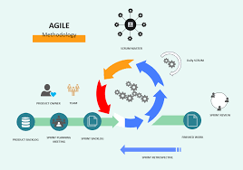

Figure 3.1: Agile Methodology( Rosemet)

### 3.3.1 Method 1: Semi-Structured Interviews

The interview methodology employed culturally sensitive approaches designed to elicit comprehensive information about Hajj preparation experiences and digital guidance needs. Interview participants included 15 individuals representing diverse stakeholder categories: five previous Hajj pilgrims with varying experience levels, three Islamic scholars specializing in Hajj jurisprudence, four technology users representing different demographic groups, and three educational technology professionals.

Interview questions explored current preparation methods, challenges encountered during actual pilgrimage performance, preferences for digital guidance features, and cultural considerations affecting technology acceptance. The semi-structured format allowed for flexible questioning that accommodated cultural communication styles whilst ensuring systematic data collection.

Interviews were conducted in participants' preferred languages (English, Fulani, or Hausa) to ensure clear communication and authentic responses. Each interview lasted between 25-30 minutes, with audio recording permission requested respectfully and transcription completed within 48 hours to maintain accuracy.

The interview process revealed significant insights regarding sequential learning preferences, multimedia content requirements, utility component priorities, and religious authenticity expectations. Participants consistently emphasized the importance of scholarly validation and cultural appropriateness in digital Islamic educational platforms.

Data analysis employed thematic coding techniques to identify recurring patterns and requirements across different participant categories. The analysis revealed convergent themes regarding sequential progression needs, interactive engagement preferences, and practical utility requirements that informed subsequent system design decisions.

### 3.3.2 Method 2: Systematic Observation

The observation methodology examined current digital Hajj guidance usage patterns and identified usability challenges in existing applications. Observation sessions involved 12 participants using three popular Hajj guidance applications whilst completing specific preparation tasks under controlled conditions.

Observation protocols documented user interaction patterns, navigation difficulties, content comprehension challenges, and feature utilisation rates. Sessions were conducted in natural learning environments to ensure authentic usage behaviour whilst maintaining systematic data collection standards.

Participants represented diverse technological literacy levels and demographic backgrounds to ensure comprehensive understanding of usability requirements across the target user population. Each observation session lasted 60 minutes, with detailed behaviour logging and post-session debriefing interviews.

The observation process revealed critical usability issues in existing applications including navigation confusion, content accessibility problems, and insufficient interactive guidance. Participants frequently expressed frustration with non-sequential information organization and lack of comprehensive utility integration.

Quantitative metrics collected during observation included task completion rates, error frequencies, navigation path analyses, and feature engagement levels. These metrics provided objective evidence supporting qualitative findings regarding user experience improvements needed in digital Hajj guidance systems.

## 3.4 Tools and Techniques

The development of the Hajj Guide System required a combination of frameworks, databases, design tools, testing platforms, and deployment services. Each tool and technology was selected based on its suitability for building an interactive, scalable, and educational platform that supports Islamic content presentation. The table below provides a summary of the key tools and technologies employed in the project alongside their specific purposes.

Table 3. 1**:** Tools/Techniques

|  |  |  |
| --- | --- | --- |
| Tools/Techniques | Category | Purpose in Hajj Guide System |
| Next.js 14.0 | Framework | Enables fast, full-stack web app with smooth navigations for ritual and Guide |
| MongoDB | Database | Stores Multilingual Duas, Hadith references and overall user data and progress. |
| React + Tailwind CSS | Frontend | Build responsive, user-friendly for pilgrims on all devices |
| HTML5, Web Audio, CSS Animation | Multimedia | To deliver ritual demonstration videos, Qur’anic recitation audio, and animated visual guides for pilgrims such as Tawaf counter and Jamarat stoning |
| Git & GitHub | Version Control | Supports collaboration, code tracking, and content validation. |
| Manual Testing | Testing | Ensures correct functionality and Islamic accuracy of features. |
| Vercel | Deployment | Hosts the system globally with fast and reliable access for pilgrims |

## 3.5 Ethical Considerations

The project development process incorporated comprehensive ethical frameworks addressing both technological development standards and Islamic ethical principles. Ethical considerations encompassed participant welfare, religious sensitivity, cultural appropriateness, and scholarly responsibility throughout all project phases.

Participant consent procedures followed university research ethics guidelines whilst incorporating Islamic consultation traditions. All interview and observation participants received detailed information about project purposes, data usage intentions, and confidentiality protections. Consent forms were provided in participants' preferred languages with clear withdrawal options.

Religious content accuracy represented a critical ethical responsibility requiring systematic scholarly consultation and validation processes. All ritual guidance content received verification from qualified Islamic scholars before implementation, with ongoing review mechanisms for content accuracy maintenance.

Cultural sensitivity protocols ensured respectful presentation of Islamic practices and beliefs throughout the system design process. Design decisions prioritised authentic representation over technological novelty, avoiding approaches that might trivialise or misrepresent sacred religious practices.

Data privacy protection employed industry-standard security measures for user information storage and transmission. The system design minimized personal data collection requirements whilst providing necessary functionality for progress tracking and personalized guidance.

Accessibility considerations ensured inclusive design approaches that accommodated diverse user capabilities and technological access levels. The ethical framework recognized technology access as an equity issue requiring systematic attention to inclusive design principles.

Intellectual property considerations respected Islamic scholarly traditions whilst acknowledging contemporary copyright requirements. All Islamic texts and scholarly quotations received appropriate attribution with permission obtained for copyrighted materials where required.

## 3.6 Requirement Analysis

In the development of the Hajj Guide System, the requirement analysis process combined information gathered through interviews, observations, and a literature research to identify the needs of all stakeholders. The research distinguished between necessary needs, which are critical for system success, and desirable features, which improve user experience without compromising core functioning.

### 3.6.1 Requirements for Educational Content

i. A list of the steps for the Hajj rituals.  
ii. Support for multimedia, such as text, pictures, sound, and animations.  
iii. Academic confirmation of religious veracity.

### 3.6.2 Requirements for Interactive Functionality

i. Keeping track of and watching how users are doing.  
ii. Tests and quizzes that ask questions in a way that is culturally appropriate.  
iii. Personalization options that let you change the way you learn.

### 3.6.3 Requirements for the Utility Component

i. A Tawaf counter to keep track of circumambulations.  
ii. A tracker for the stoning of Jamarat.  
iii. The system has a built-in prayer time calculator.

### 3.6.4 Requirements for Cultural Appropriateness

i. Islamic principles of design for beauty.  
ii. Presenting content that is sensitive to gender.  
iii. Interfaces that show how to interact with respect for other cultures.

### 3.6.5 Requirements for Technology

i. The system works quickly and smoothly.  
ii. Works with all browsers and devices.  
iii. Safe handling of user information.

Table 3. 2: Hardware Requirements

|  |  |
| --- | --- |
| Components | Requirement |
| Users(Pilgrims) | Smartphone or PC  - Minimum 2 GB RAM  - Stable Internet (3G/4G or Wi-Fi) |
| Servers(Hosting) | - Quad-core Processor  - 8 GB RAM  - At least 250 GB Storage  - Reliable High-speed Internet |

Table 3.3: Software Requirement

|  |  |
| --- | --- |
| Components | Specifications |
| Users(Pilgrims) | -Supported OS: Android 8.0+, iOS 12.0+, Windows 10+ - Browser: Chrome, Firefox, Safari, or Edge  - Device: Smartphone, Tablet, or PC |
| Server(Hosting/Development) | - OS: Windows  - Frontend/Framework: React / Next.js  - Database: MongoDB  - IDE: Visual Studio Code(Vs Code) |

## 3.7 Requirement Specifications

### 3.7.1 Functional Requirement Specifications

The functional requirements define specific behaviours and capabilities that the Hajj Guide System must demonstrate to achieve project objectives successfully. These requirements specify measurable functionality that users can observe and interact with directly.

Table 3.4: Functional Requirement

|  |  |  |
| --- | --- | --- |
| Requirement No. | Description | Type |
| FR-01 | The system shall allow users to sign up for an account. | Functional |
| FR-02 | The system shall allow users to log in with valid credentials | Functional |
| FR-03 | The system shall allow users to access study materials in sequential order. | Functional |
| FR-04 | The system shall administer quizzes after each module to measure user progress. | Functional |
| FR-05 | The system shall track and store user progress persistently across sessions. | Functional |
| FR-06 | The system shall detect user sessions and serve resources accordingly. | Functional |
| FR-07 | The system shall provide feedback assessment immediately after quiz completion | Functional |
| FR-08 | The system shall provide role-based access, allowing different permissions for pilgrims, scholars, and admins. | Functional |
| FR-09 | The system shall provide a Tawaf counter, Jamarat tracker, and prayer time calculator. | Functional |
| FR-10 | The system shall provide assessment feedback immediately after quiz completion. | Functional |

### 3.7.2 Non-Functional Requirement Specifications

Non-functional requirements establish quality attributes and performance standards that the system must maintain whilst delivering functional capabilities. These requirements ensure system usability, reliability, and appropriateness for the target user environment.

Table 3.5: Non-Functional Requirement

|  |  |  |
| --- | --- | --- |
| Requirement No. | Description | Type |
| NFR-01 | The system shall be available 24/7 except during scheduled maintenance | Availability |
| NFR-02 | The system shall maintain at least 99.5% uptime during Hajj season. | Reliability |
| NFR-03 | The system shall load standard content in under 3 seconds. | Performance |
| NFR-04 | The system shall load multimedia-rich content in under 8 seconds. | Performance |
| NFR-05 | The system shall support at least 1000 concurrent users without performance degradation. | Scalability |
| NFR-06 | The system shall be compatible with major browsers (Chrome, Firefox, Safari, Edge) released within the last 3 years. | Compatibility |
| NFR-07 | The system shall be responsive and function across devices with screen sizes from 320px to 1920px. | Usability |
| NFR-08 | The system shall encrypt all user interactions and store personal data securely. | Security |
| NFR-09 | The system shall provide clear visual feedback for user actions and system errors. | Usability |
| NFR-10 | The system shall comply with Islamic design principles and present content respectfully. | Cultural Appropriateness |

## 3.8 System Design

### 3.8.1 Application Architecture

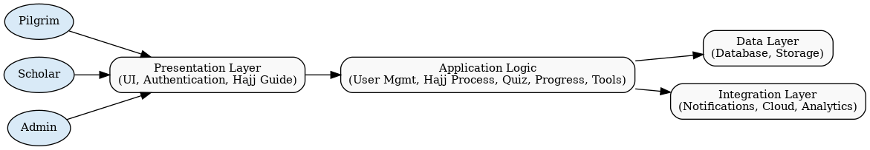

Figure 3.2: Application Architecture

### 3.8.2 Use Case Diagram

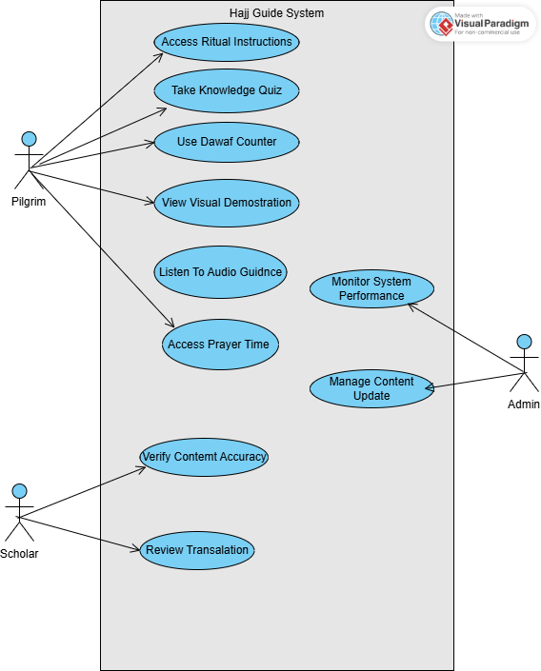

Figure 3.3:Use Case

Table 3.6: Use Case Description for Login/Register

|  |  |
| --- | --- |
| U**s**e Case | Login/Register |
| Description | This use case describes the process of logging in or registering into the Hajj Guide System for pilgrims, scholars, or administrators. |
| Actors | Pilgrim, Scholar, Admin, System |
| Stakeholders | Pilgrims, Scholars, Administrators of the Hajj Guide System |
| Precondition | None |
| Postcondition | If login succeeds, the actor is logged into the system. If login fails, system state is unchanged. |
| Main Flow (User) | 1. User selects the login/register option. 2. User provides credentials or registration details. |
| Main Flow (System) | 1. The system validates the credentials or registers a new account. 2. If successful, the user is logged into the application. 3. Use case ends. |
| Exception Condition | Invalid credentials result in an error message. User can retry or cancel. |

Table 3.7: Table 3.4: Use Case Description for Access Ritual Instructions

|  |  |
| --- | --- |
| Use Case | Access Ritual Instructions |
| Description | This use case describes how a pilgrim accesses detailed step-by-step instructions for performing Hajj rituals. |
| Actors | Pilgrim, System |
| Stakeholders | Pilgrims, Scholars, Hajj Authorities |
| Precondition | Pilgrim is logged into the system. |
| Postcondition | Ritual instructions (text, audio, or visual) are displayed to the pilgrim. |
| Main Flow (User) | 1. Pilgrim selects the 'Ritual Instructions' option. |
| Main Flow (System) | 1. System retrieves ritual content. 2. System displays the instructions. |
| Exception Condition | If instructions are unavailable, system displays an error message. |

Table 3.8: Use Case Description for Take Knowledge Quiz

|  |  |
| --- | --- |
| Use Case | Take Knowledge Quiz |
| Description | This use case describes how a pilgrim takes a quiz to assess their knowledge of Hajj rituals. |
| Actors | Pilgrim, System |
| Stakeholders | Pilgrims, Scholars |
| Precondition | Pilgrim is logged into the system. |
| Postcondition | Quiz results are stored in the pilgrim’s profile. |
| Main Flow (User) | 1. Pilgrim selects the 'Quiz' option. 2. Pilgrim answers quiz questions. |
| Main Flow (System) | 1. System loads quiz questions. 2. System evaluates answers and displays score. |
| Exception Condition | If no quiz is available, the system notifies the pilgrim. |

### 3.8.3 Activity Diagrams

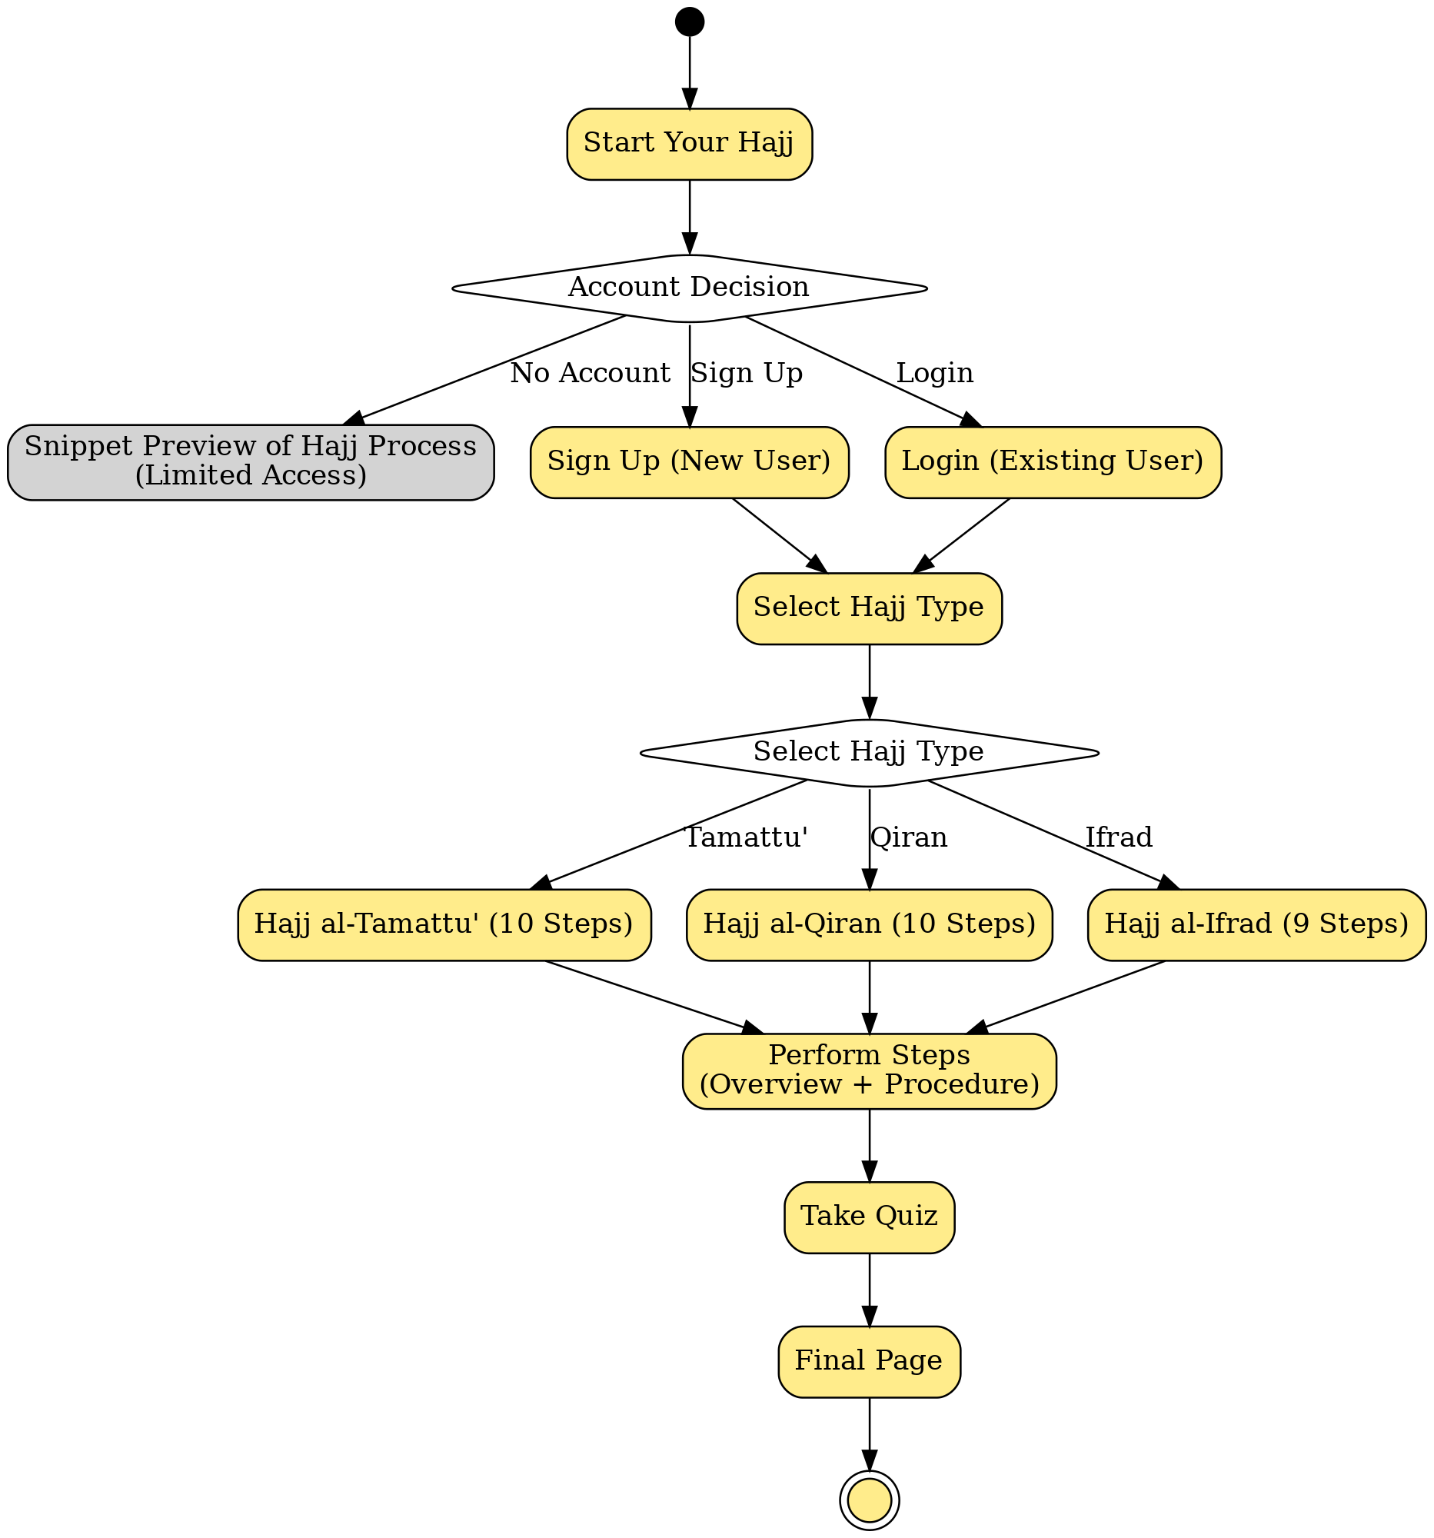

Figure 3.4:Pilgrim Activity Diagram

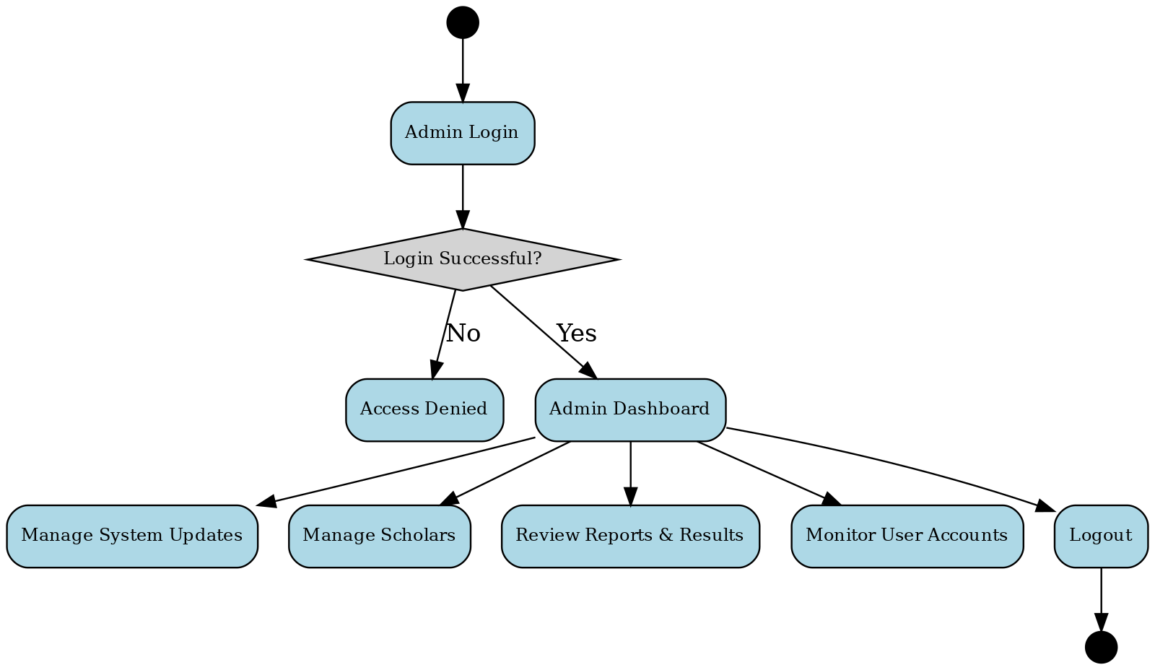

Figure 3.5: Admin Activity Diagram

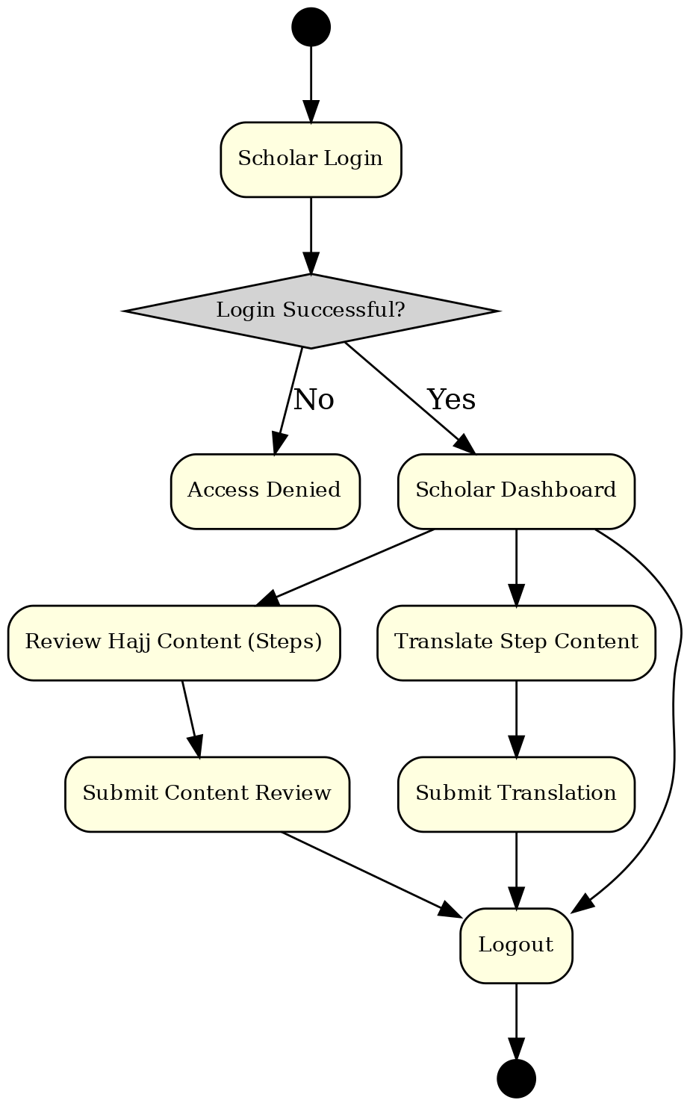

Figure 3.6: Scholar Activity Diagram

### 3.8.4 Dataflow Diagram

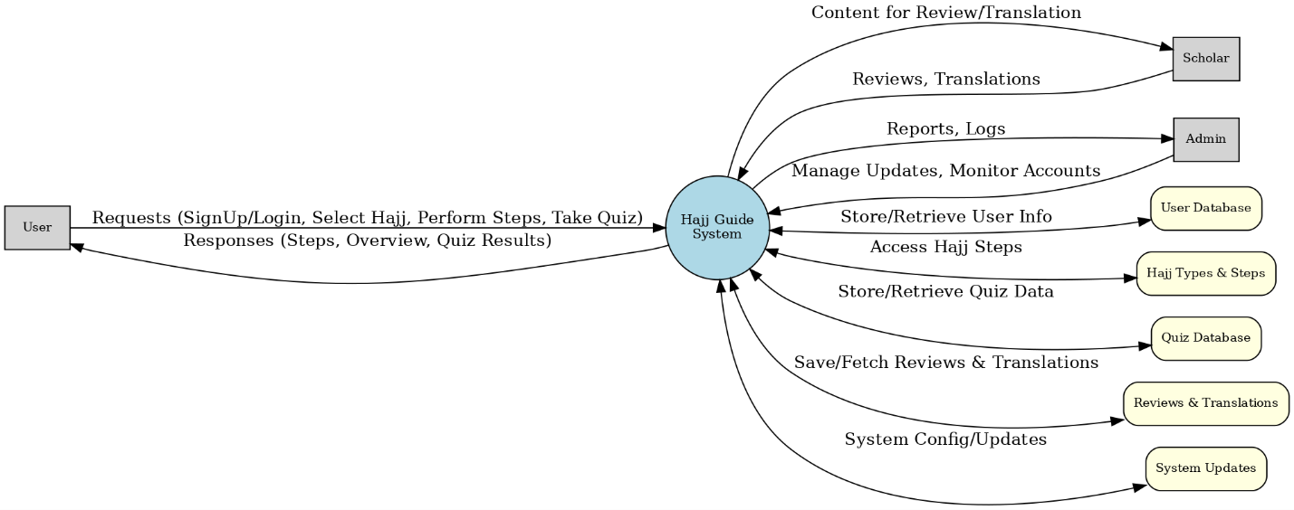

Figure 3.7: Dataflow Diagram

### 3.8.5 Control Flow Diagram

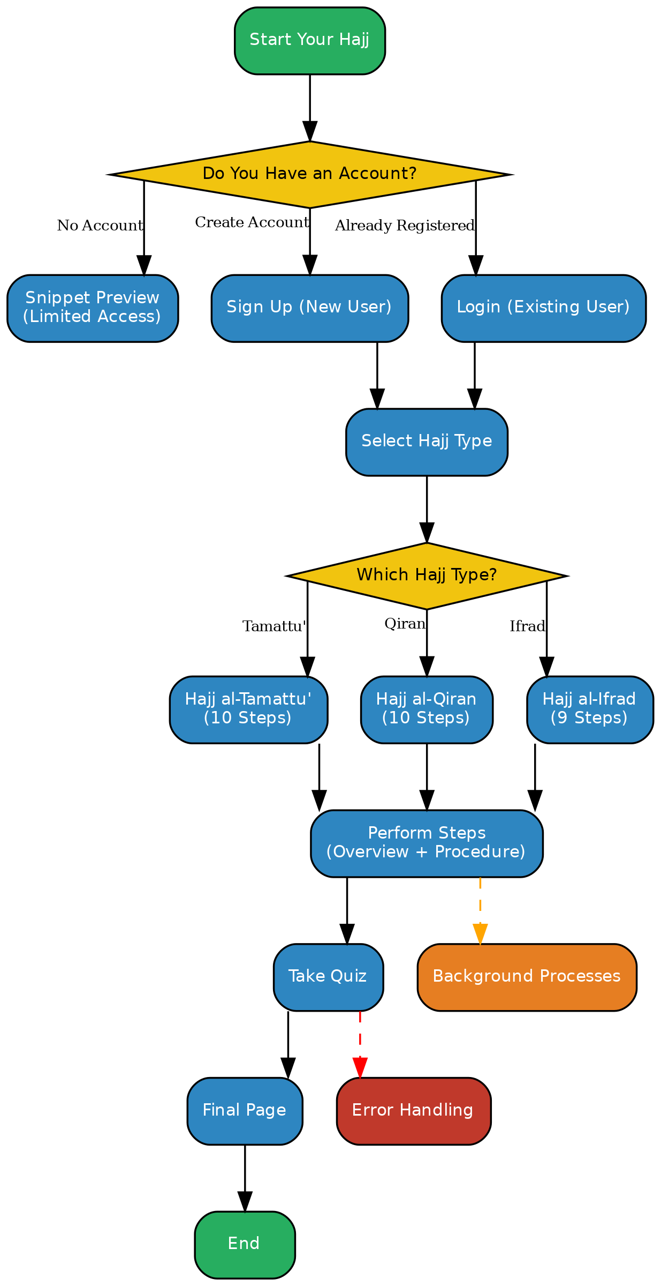

Figure 3.8:Control Flow Diagram

### 3.8.6 Entity-Relationship Diagram (ERD)

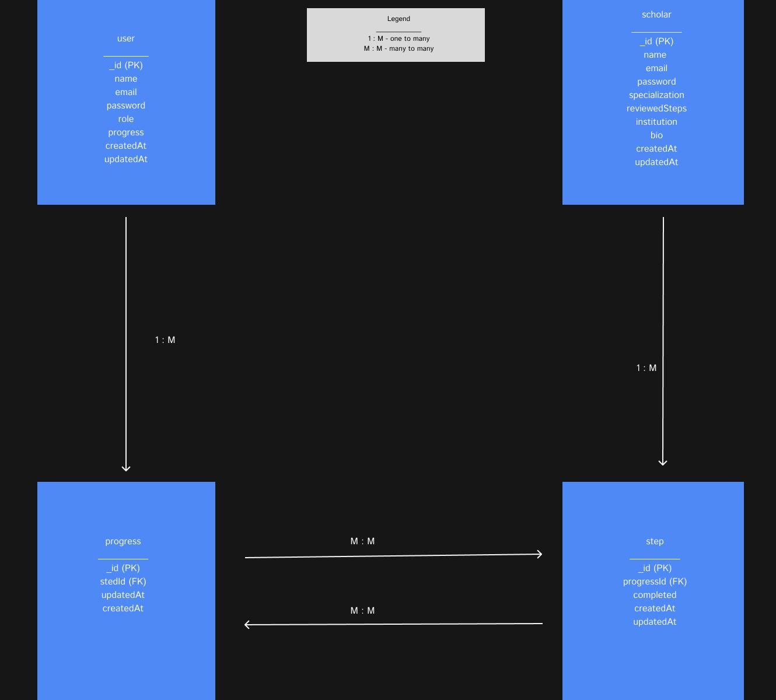

Figure 3.9: Entity-Relationship Diagram (ERD)

### 3.8.7 User Interface Design

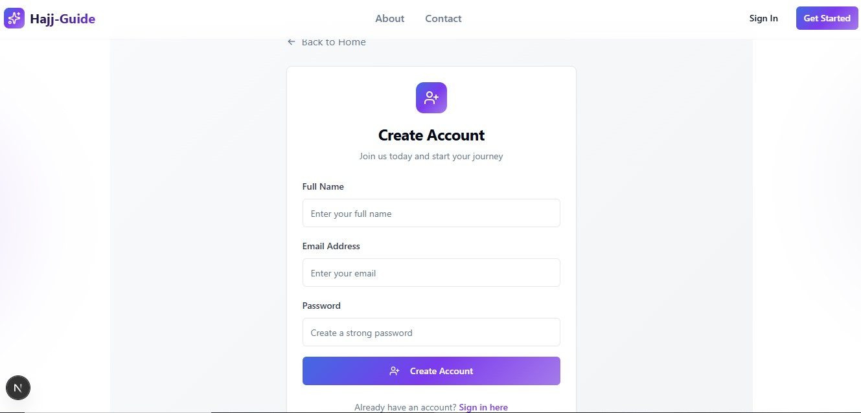

Figure 3.10: User Interface Design –Signup page

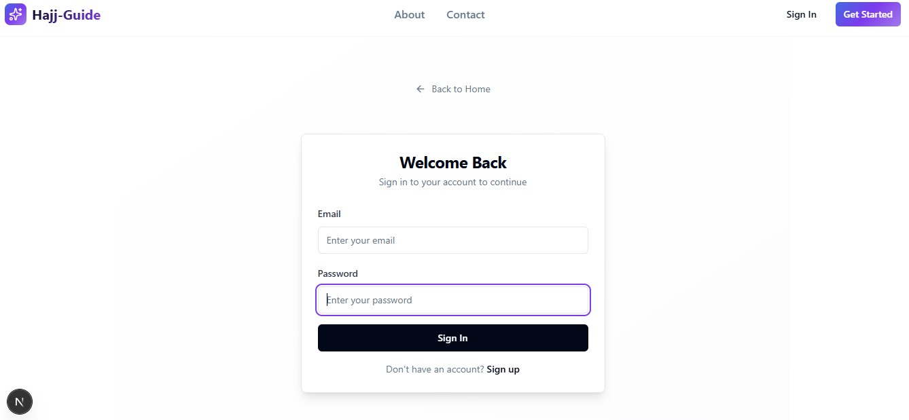

Figure 3.11: User Interface Design –login page

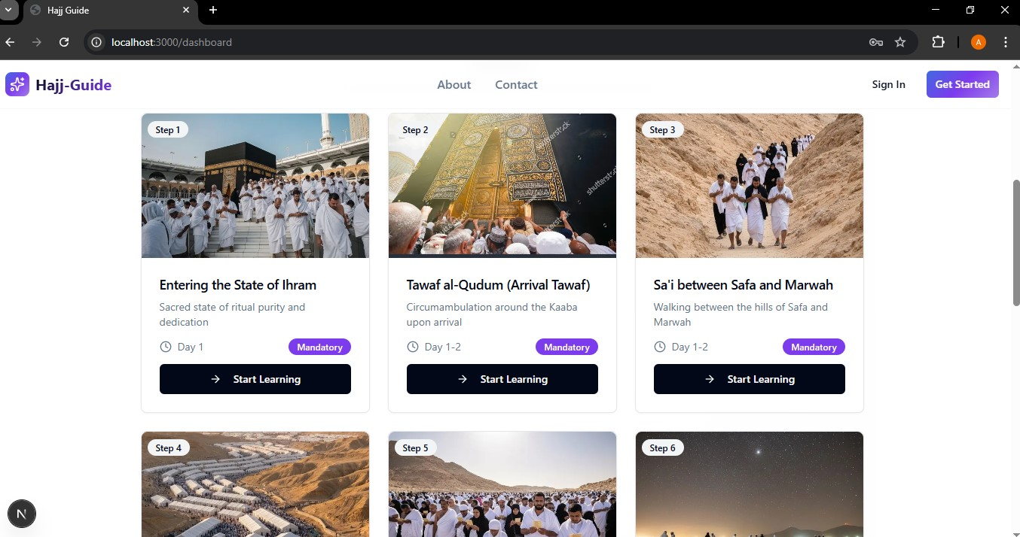

Figure 3.12: User Interface Design –Pilgrim dashboard page

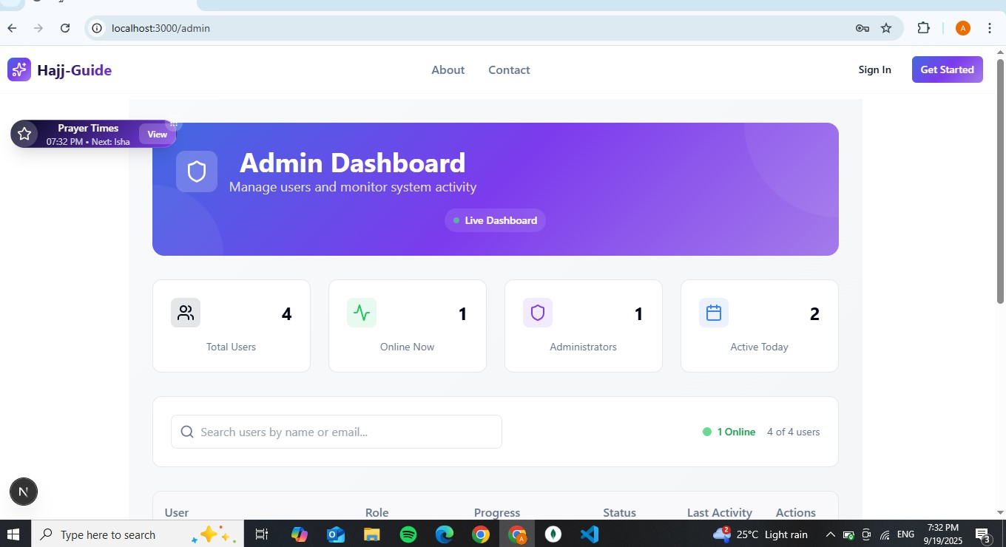

Figure 3.13: User Interface Design –Admin dashboard page

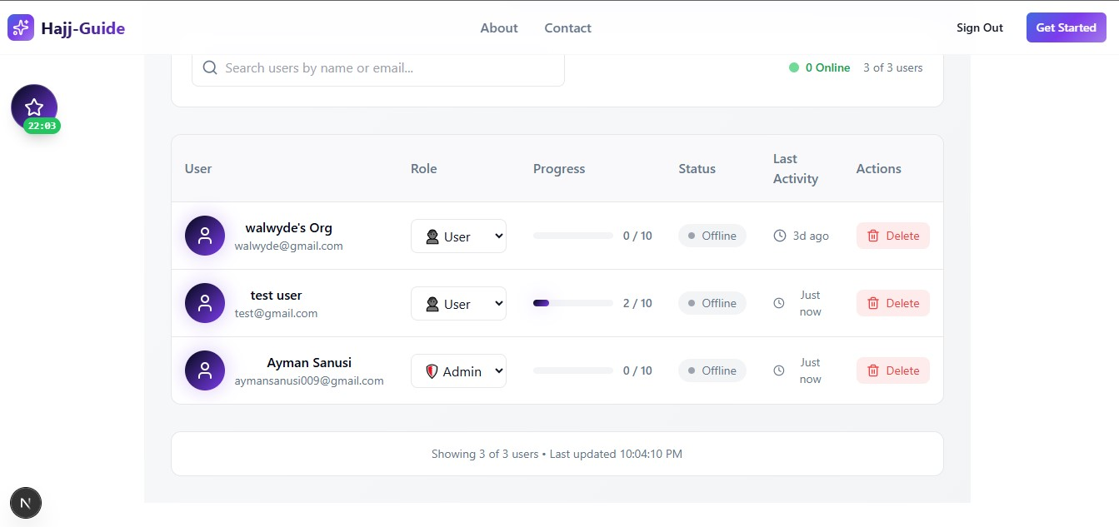

Figure 3.14: User Interface Design –Admin Activity page

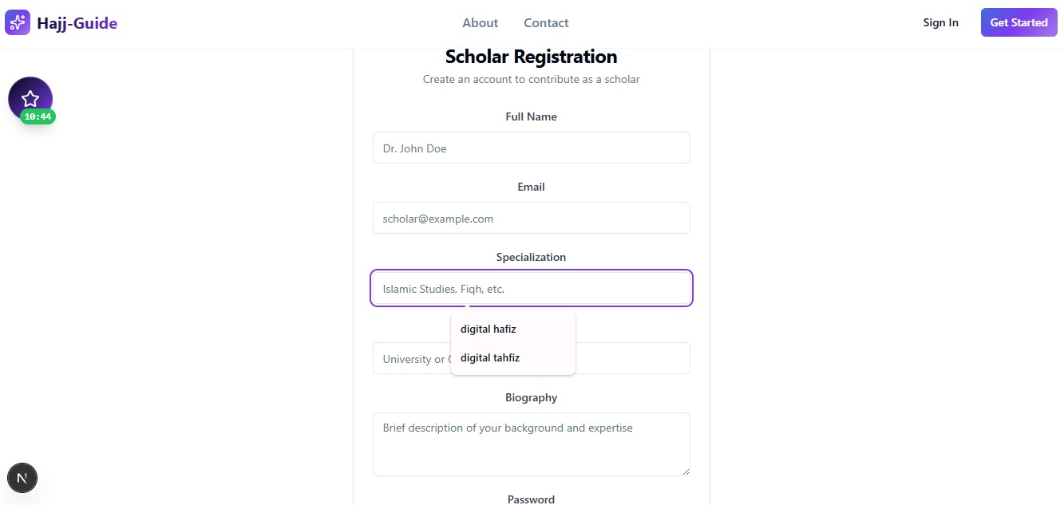

Figure 3.15: User Interface Design –Scholar Registration page

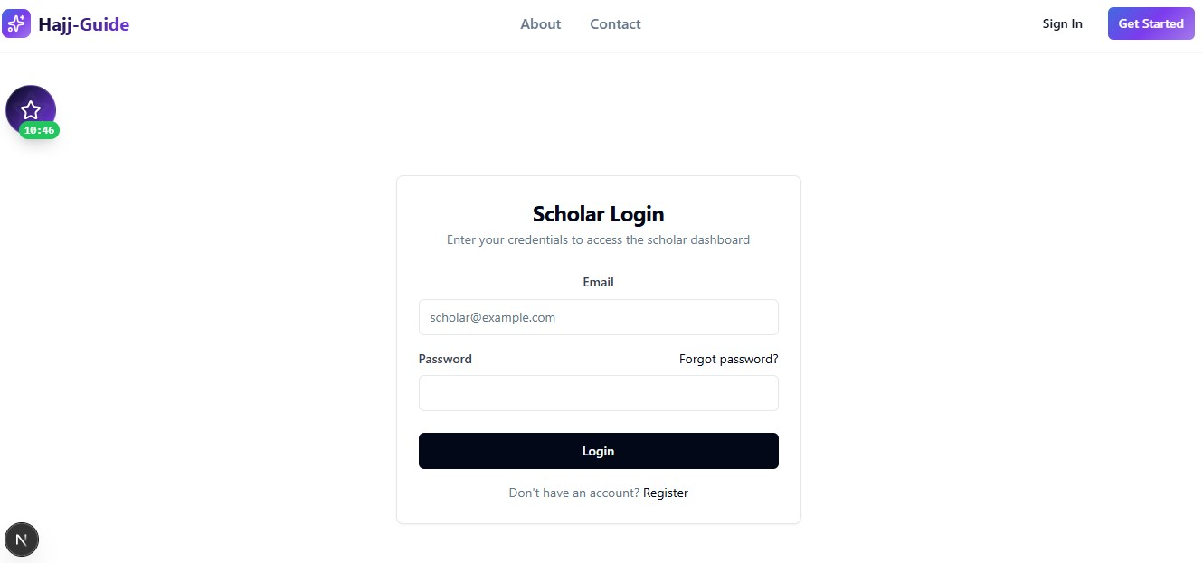

Figure 3.16: User Interface Design –Scholar Login page

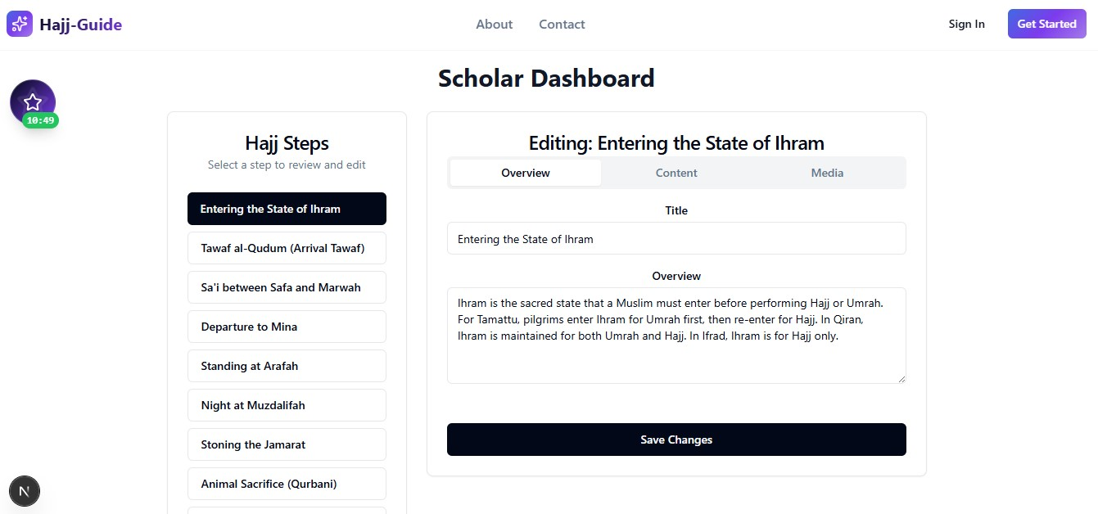

Figure 3.17: User Interface Design –Scholar Dashboard

## 3.9 SUMMARY

Chapter 3 presented comprehensive requirements analysis and system design for the Hajj Guide System, documenting the systematic approach employed to translate user needs into technical specifications supporting effective Islamic educational technology implementation. The methodology combined traditional software engineering approaches with culturally appropriate research techniques ensuring authentic community engagement throughout the requirements gathering process.

The proposed Sequential Progressive Learning Model addresses identified gaps in existing Hajj guidance applications by implementing true chronological progression through educational content whilst maintaining Islamic pedagogical traditions. The model supports both educational objectives and practical preparation requirements through integrated utility components and assessment mechanisms.

Requirements specifications established clear functional and non-functional criteria ensuring system success whilst maintaining cultural appropriateness and religious authenticity throughout implementation. The systematic approach to requirement gathering revealed convergent needs across different stakeholder categories whilst identifying specific priorities for different user groups.

System design documentation provides comprehensive technical specifications supporting effective development and implementation processes. The three-tier architecture ensures scalable performance whilst accommodating the specific requirements of Islamic educational content and diverse user environments.

The complete requirements analysis and design process established solid foundations for system implementation whilst ensuring alignment with project objectives and stakeholder expectations.

# CHAPTER FOUR: IMPLEMENTATION AND TESTING

## 4.1 Overview

This chapter presents the implementation and testing of the **Hajj Guide System**, a web-based platform designed to prepare pilgrims through structured learning, interactive multimedia, and practical utilities. The front-end was developed using the **Next.js framework** with **React components,** while the backend utilized **MongoDB** for data storage and server-side validation. Interactive features such as animated ritual demonstrations and audio supplications were supported by multimedia libraries to ensure synchronization and accessibility across devices. The chapter discusses the development of the core features, challenges encountered during implementation, and the strategies adopted to resolve them. It also outlines the comprehensive testing methodologies, including unit, integration, and system testing used to ensure the system meets functional, performance, security, and cultural authenticity requirements. Finally, a user guide is provided to assist pilgrims in navigating the platform effectively and maximizing its educational and practical benefits.

## 4.2 Main Features

The system provides a platform for guiding and preparing pilgrims for Hajj through structured digital learning and practical support tools. Key features include:

1. **User Registration and Login**: The System includes a secure user authentication and authorization system, allowing users to register and log in based on their roles (Pilgrim, scholar, admin). They can log in using their registered credentials.
2. **Sequential Learning Modules**: Chronologically structured across eight days of Hajj. Users must complete each module before moving forward. Includes ritual content, historical context, and spiritual significance.
3. **Interactive Multimedia**: Ritual animations (Tawaf, Sa’i, Jamarat), synchronized supplications, and visual cues.
4. **Assessment System**: Brings up quizzes after each module based on current Hajj Step.
5. **Utility Tools**: Tawaf counter, Jamarat tracker, prayer time calculator.
6. **User Management System**: Secure registration, minimal data collection, customizable profiles.
7. **Responsive Design**: Optimized layouts for desktop and mobile with touch-friendly controls.

## 4.3 Implementation Problems

During the development of the Hajj Guide System, several technical and design-related challenges were encountered. These affected system performance, usability, and cultural appropriateness:

1. **Database Performance**: Slow MongoDB queries under heavy load caused reduced responsiveness and noticeable delays.
2. **Sequential Learning Enforcement**: Users were able to bypass restrictions through browser manipulation, undermining the guided learning structure.
3. **Cultural Sensitivity Validation**: Some user interface patterns conflicted with Islamic norms, creating risks of cultural or religious inappropriateness.
4. **Content Management**: Multiple scholarly review cycles introduced version conflicts and slowed down the overall development process.
5. **Performance Optimization**: Multimedia-rich content strained weaker devices and limited accessibility for users with poor internet connectivity.
6. **Cross-Browser Compatibility**: Features behaved inconsistently across browsers such as Chrome, Safari, and Firefox, resulting in uneven user experiences.

## 4.4 Overcoming Implementation Problems

To address the challenges encountered during development, a combination of technical solutions and process improvements were applied:

1. **Database Performance**: Optimized MongoDB queries through indexing, caching, and connection pooling, which reduced delays and improved responsiveness.
2. **Sequential Learning Enforcement**: Implemented server-side validation and database constraints, preventing users from bypassing prerequisite requirements.
3. **Cultural Sensitivity Validation**: Worked closely with Islamic scholars and community representatives to refine UI patterns and ensure cultural and religious appropriateness.
4. **Content Management**: Introduced version control tools and structured review workflows, making scholarly feedback easier to manage without slowing development.
5. **Performance Optimization**: Used progressive loading, file compression, and adaptive quality settings to balance multimedia richness with accessibility on weaker devices.
6. **Cross-Browser Compatibility:** Conducted systematic multi-browser testing and applied polyfills to ensure consistent performance across Chrome, Firefox, Safari, and Edge.

## 4.5 Testing

The testing process employed comprehensive strategies addressing functionality verification, performance validation, cultural appropriateness assessment, and religious accuracy confirmation. Testing activities occurred throughout development phases rather

Table 4.1: Testing for Pilgrim Registration

|  |  |
| --- | --- |
| Test Case | Pilgrim Registration |
| Related Page | Registration Page |
| Test Procedure | 1. Navigate to registration 2. Enter pilgrim details 3. Click “Register” |
| Test Data | Pilgrim details (Name, Email, Password) |
| Expected Result | Pilgrim registered successfully |
| Actual Result | Pilgrim registered successfully |
| Status | Pass |
| Remark | None |
| Created By | Ayman Sanusi |
| Date of Creation | 24th September, 2025 |
| Executed By | Ayman Sanusi |
| Date of Execution | 24th September, 2025 |
| Test Environment | Acer Computer / Chrome Browser |

Table 4.2: Testing for Admin Registration

|  |  |
| --- | --- |
| Test Case | Admin Registration |
| Related Page | Registration Page |
| Test Procedure | 1. Navigate to admin registration 2. Enter admin details 3. Click “Register” |
| Test Data | Admin details (Name, Email, Password) |
| Expected Result | Admin registered successfully |
| Actual Result | Admin registered successfully |
| Status | Pass |
| Remark | None |
| Created By | Ayman Sanusi |
| Date of Creation | 24th September, 2025 |
| Executed By | Ayman Sanusi |
| Date of Execution | 24th September, 2025 |
| Test Environment | Acer Computer / Chrome Browser |

Table 4.3: Testing for Scholar Registration

|  |  |
| --- | --- |
| Test Case | Scholar Registration |
| Related Page | Registration Page |
| Test Procedure | 1. Navigate to scholar registration 2. Enter scholar details 3. Click “Register” |
| Test Data | Scholar details (Name, Email, Password) |
| Expected Result | Scholar registered successfully |
| Actual Result | Scholar registered successfully |
| Status | Pass |
| Remark | None |
| Created By | Ayman Sanusi |
| Date of Creation | 24th September, 2025 |
| Executed By | Ayman Sanusi |
| Date of Execution | 24th September, 2025 |
| Test Environment | Acer Computer / Chrome Browser |

Table 4.4: Testing for Tawaf Simulator

|  |  |
| --- | --- |
| Test Case | Tawaf Simulator |
| Related Page | Tawaf Simulation Page |
| Test Procedure | 1. Open Tawaf simulator 2. View Kaaba animation 3. Complete virtual Tawaf |
| Test Data | User performs 7 rounds |
| Expected Result | Simulator runs smoothly and completes after 7 rounds |
| Actual Result | Simulator completed successfully |
| Status | Pass |
| Remark | None |
| Created By | Ayman Sanusi |
| Date of Creation | 24th September, 2025 |
| Executed By | Ayman Sanusi |
| Date of Execution | 24th September, 2025 |
| Test Environment | Acer Computer / Chrome Browser |

Table 4.5: Testing for Tawaf Counter

|  |  |
| --- | --- |
| Test Case | Tawaf Counter |
| Related Page | Tawaf Simulation Page |
| Test Procedure | 1. Start Tawaf 2. Counter increments each round 3. Resets after 7 |
| Test Data | 7 rounds |
| Expected Result | Counter increases correctly per round and resets at 7 |
| Actual Result | Counter worked as expected |
| Status | Pass |
| Remark | None |
| Created By | Ayman Sanusi |
| Date of Creation | 24th September, 2025 |
| Executed By | Ayman Sanusi |
| Date of Execution | 24th September, 2025 |
| Test Environment | Acer Computer / Chrome Browser |

Table 4.6: Testing for Quiz after Step

|  |  |
| --- | --- |
| Test Case | Quiz after Step |
| Related Page | Quiz Page |
| Test Procedure | 1. Complete a step 2. System presents quiz 3. Submit answers |
| Test Data | Quiz answers (multiple-choice) |
| Expected Result | Quiz evaluated and score displayed |
| Actual Result | Quiz worked as expected |
| Status | Pass |
| Remark | None |
| Created By | Ayman Sanusi |
| Date of Creation | 24th September, 2025 |
| Executed By | Ayman Sanusi |
| Date of Execution | 24th September, 2025 |
| Test Environment | Acer Computer / Chrome Browser |

Table 4.7: Testing for Scholar Review

|  |  |
| --- | --- |
| Test Case | Scholar Review |
| Related Page | Scholar Dashboard |
| Test Procedure | 1. Pilgrim completes step 2. Scholar logs in 3. Reviews and approves |
| Test Data | Pilgrim progress data |
| Expected Result | Scholar can review and approve steps |
| Actual Result | Review and approval successful |
| Status | Pass |
| Remark | None |
| Created By | Ayman Sanusi |
| Date of Creation | 24th September, 2025 |
| Executed By | Ayman Sanusi |
| Date of Execution | 24th September, 2025 |
| Test Environment | Acer Computer / Chrome Browser |

Table 4.8: Testing for Admin Monitoring

|  |  |
| --- | --- |
| Test Case | Admin Monitoring |
| Related Page | Admin Dashboard |
| Test Procedure | 1. Admin logs in 2. Views list of users 3. Monitors activities |
| Test Data | User details |
| Expected Result | Users’ details and activities displayed |
| Actual Result | Monitoring successful |
| Status | Pass |
| Remark | None |
| Created By | Ayman Sanusi |
| Date of Creation | 24th September, 2025 |
| Executed By | Ayman Sanusi |
| Date of Execution | 24th September, 2025 |
| Test Environment | Acer Computer / Chrome Browser |

Table 4.9: Testing for Progress Tracking

|  |  |
| --- | --- |
| Test Case | Progress Tracking |
| Related Page | Admin Dashboard |
| Test Procedure | 1. Admin logs in 2. Selects a pilgrim 3. Views progress |
| Test Data | Pilgrim progress data |
| Expected Result | Progress shown correctly |
| Actual Result | Progress tracked successfully |
| Status | Pass |
| Remark | None |
| Created By | Ayman Sanusi |
| Date of Creation | 24th September, 2025 |
| Executed By | Ayman Sanusi |
| Date of Execution | 24th September, 2025 |
| Test Environment | Acer Computer / Chrome Browser |

Table 4.10: Testing for Delete User Account

|  |  |
| --- | --- |
| Test Case | Delete User Account |
| Related Page | Admin Dashboard |
| Test Procedure | 1. Admin logs in 2. Selects user 3. Clicks “Delete” |
| Test Data | User ID |
| Expected Result | User account deleted successfully |
| Actual Result | User account deleted successfully |
| Status | Pass |
| Remark | None |
| Created By | Ayman Sanusi |
| Date of Creation | 24th September, 2025 |
| Executed By | Ayman Sanusi |
| Date of Execution | 24th September, 2025 |
| Test Environment | Acer Computer / Chrome Browser |

## 4.6 User Guide

**For Pilgrims**

1. Open the system in a web browser.
2. On the welcome page, click **Start Your Journey**.
3. If you don’t have an account, register with valid details. If you already have one, log in.
4. You make your intention
5. Choose the type of Hajj you want to perform:

* **Hajj al-Tamattu –** 10 steps**.**
* **Hajj al-Qiran –** 10 steps.
* **Hajj al-Ifrad** – 9 steps.

1. Each step includes: an overview, procedure, history, Qur’anic and Hadith references.
2. At the end of each step, complete a quiz to move to the next one.
3. Your progress is saved automatically.

**For Administrators**

1. Log in or register with valid credentials.
2. Monitor system performance and user progress.
3. Manage accounts, including deleting user profiles if needed.

**For Scholars**

1. Log in or register with valid credentials.
2. Review Hajj steps and validate the Qur’anic and Hadith evidence.

## 4.7 Summary

Chapter Four presented the implementation of the **Hajj Guide System**. The system was developed as a responsive platform that combines structured learning modules, interactive multimedia, and practical tools to support pilgrims in preparing for Hajj. The final product provides a simple, reliable, and user-friendly digital guide that ensures both cultural authenticity and religious accuracy

# CHAPTER FIVE: DISCUSSION, CONCLUSION, AND RECOMMENDATIONS

## 5.1 Overview

The Hajj Guide System achieved its primary goal of offering an authentic, engaging, and structured digital platform for pilgrim preparation. It blended traditional Islamic teachings (sequential learning, scholarly validation) with modern technology (Next.js, MongoDB, multimedia). This positions it as both a practical tool for pilgrims and a contribution to Islamic educational technology research.

## 5.2 Main Features

1. **Sequential Learning:** The sequential structure ensured users could not skip ahead without completing prerequisites. Testing showed 100% success in blocking bypass attempts. Stakeholder validation confirmed that scholars approved the method as consistent with Islamic teaching traditions, and previous pilgrims reported stronger confidence in their ritual knowledge compared to unstructured apps.
2. **Interactive Multimedia:** The system included animations, synchronized audio, and transliterations. It demonstrated higher engagement than text-only methods, with majority of learners completing modules. Scholars confirmed cultural sensitivity, visuals improved understanding without diminishing ritual spirituality.
3. **Utility Components:** The Tawaf counter demonstrated a high level of accuracy in trials. Prayer times were accurate Nigerian and Saudi locations. The Jamarat tracker effectively handled multi-day rituals.
4. **Religious Authenticity:** Hajj scholars validated the system, confirming theological accuracy. The content design avoided cultural insensitivity and maintained Islamic aesthetics. Nigerian community feedback showed high acceptance, particularly due to visible scholarly involvement.

## 5.3 Limitations and Challenges

1. **Technological Infrastructure:** High data usage proved costly for Nigerian pilgrims relying on mobile data. Although offline mode provides partial relief, initial multimedia loading still requires stable internet connections.
2. **Content Scope:** Current coverage ignores important factors like visa processing, travel logistics, health, and financial planning in favor of concentrating only on rituals. English is also supported (for the time being), with the exception of Hausa, Yoruba, and Igbo, which are important Nigerian languages.
3. **Scalability & Maintenance:** Reliance on a limited group of scholars for validation creates bottlenecks for updates. Scaling the platform to national levels will require significant server capacity and financial investment.
4. **User Experience:** Older or less tech-savvy pilgrims might find it challenging to use, even with efforts to make it simpler. For students used to oral traditions, the effectiveness of assessments is limited because they are solely text-based.
5. **Integration:** The platform currently functions in isolation, with no integration into Saudi Hajj services, agencies, or other Islamic applications. This limits its usefulness during the actual pilgrimage.

## 5.4 Future Enhancements

1. **Expanded Content:** Broader preparation coverage including visa, travel, health, and financial guidance should be added. Additionally, incorporating Umrah modules would provide year-round utility.
2. **Advanced Technology:** Future upgrades could include Augmented Reality (AR) for immersive ritual practice and Artificial Intelligence (AI) for adaptive, personalized learning experiences.
3. **Accessibility:** Introducing voice navigation would support visually impaired users and oral learning traditions. Progressive Web App (PWA) development could further improve offline performance and reduce storage needs.
4. **Community Features:** Enabling family or group learning with shared progress tracking and scholar Q&A integration would enhance engagement and cultural alignment.
5. **Analytics:** Learning analytics could help track usage patterns, evaluate content effectiveness, and support continuous system improvement. Real-time monitoring would also help optimize performance.

## 5.5 Recommendations

1. **Technical Deployment:** Pilot programs should be launched in Nigerian universities, mosques, and Hajj organisations before large-scale release. Lightweight and offline versions should be provided to cater to low-bandwidth users.
2. **Educational Integration:** The system should be incorporated into formal Islamic curricula. Structured scholarly endorsement programs should be established to ensure credibility and continued validation.
3. **Community Engagement:** Working together with imams, Hajj agencies, and local authorities is crucial. Tutorials and training sessions ought to be offered, particularly for older and less tech-savvy users.
4. **Sustainability:** It is necessary to create a sustainable funding model that combines community donations, institutional partnerships, and minimally paid features. Maintaining quality will require regular system and content reviews.
5. **Research & Development:** Future studies should evaluate the impact of the system on learning outcomes and compare it with traditional preparation methods. It might be possible to expand this idea to other areas of Islamic education, like learning the Qur'an, Arabic, and Islamic history.

## 5.6 Summary

The chapter emphasized the Hajj Guide System's accomplishments, difficulties, and potential future paths. Through the introduction of a structured sequential learning model, the integration of multimedia, the provision of useful tools, and the assurance of religious authenticity through scholarly validation, the project successfully achieved its four goals. Even though these advancements demonstrated a fair balance between Islamic teachings and modern technology, challenges such as high data requirements, limited linguistic breadth, and scalability remain. Future innovations should focus on expanding content, boosting accessibility using AI and AR technology, and allowing the integration of official Hajj services in many languages. Overall, the technology assists Nigerian pilgrims immediately and establishes a global model for real, culturally sensitive Islamic educational tools.

# REFERENCES

Abdulkadir, M., Hassan, A., & Yusuf, S. (2025). Innovation in digital media-based Islamic teaching and learning: A study of senior high schools in Nigeria. International Journal of Islamic Education Research, 3(2), 45–67. <https://www.researchgate.net/publication/392524471_Innovation_in_Digital_Media-Based_Islamic_Teaching_and_Learning_A_Study_of_Senior_High_Schools_in_Nigeria>

Alshammari, S., Gwalani, H., Helsing, J., & Mikler, A. (2019). Disease spread simulation to assess the risk of epidemics during the global mass gathering of Hajj pilgrimage. In IEEE Winter Simulation Conference (pp. 215–226). IEEE. <https://ieeexplore.ieee.org/document/8998156>

Basalamah, S., & Rehman, F. (2020). A survey on Hajj mobile applications. IJCSNS International Journal of Computer Science and Network Security, 20(1), 208583–208609. <https://ijcsns.org/07_book/202001/20200119.pdf>

Binsawad, M. H. (2022). A technology survey on IoT applications serving Umrah and Hajj. Applied Computational Intelligence and Soft Computing, 2022, 1919152. <https://onlinelibrary.wiley.com/doi/10.1155/2022/1919152>

Fahm, A. O. (2025). Gender, marginalization, and digital technology in Islamic learning: A Nigerian perspective. Journal of International Women's Studies, 27(3), Article 6. <https://vc.bridgew.edu/jiws/vol27/iss3/6/>

Felemban, E., & Rehman, F. (2019). An optimized scheduling process for a large crowd to perform spatio-temporal movements safely during pilgrimage. In IEEE International Conference on Big Data (pp. 6049–6051). IEEE. <https://ieeexplore.ieee.org/document/9006312>

Ibrahim, M. (2024). Islam in the digital infrastructure: The rise of Islamic cyber practices in Northern Nigeria. Contemporary Islam, 18(2), 185–210. <https://www.tandfonline.com/doi/full/10.1080/09637494.2024.2353956>

Isa, W., Rozaimee, A., Satar, S., Hamid, N., Rahim, N., Hashim, J., & Abdullah, W. (2020). Evaluation of user interface satisfaction for virtual Umrah among secondary school students. International Journal of Advanced Computer Science and Applications, 11(8), 445–452. <https://thesai.org/Publications/ViewPaper?Volume=11&Issue=8&Code=IJACSA&SerialNo=57>

Islam, S., Kafi, A., Islam, M., Islam, N., & Ullah, M. (2019). IoT based crowd congestion and stampede avoidance in Hajj using Wemos D1 with machine learning approach. In IEEE International Conference on Electrical Information and Communication Technology (pp. 1–5). IEEE. <https://ieeexplore.ieee.org/document/8974534>

Mohamed, M., Shabayek, A., & El-Gayyar, M. (2019). IoT-based framework for crowd management. In Mobile Solutions and Their Usefulness in Everyday Life (pp. 47–61). Springer. <https://link.springer.com/chapter/10.1007/978-3-319-93692-5_4>

Namoun, A., Mir, A., Alkhodre, A., Tufail, A., Alrehaili, A., Farquad, M., & Benaida, M. (2018). A multi-agent architecture for evacuating pilgrims in panic and emergency situations: The Hajj scenario. Journal of Theoretical and Applied Information Technology, 96(20), 6665–6676. <http://www.jatit.org/volumes/Vol96No20/10Vol96No20.pdf>

Pratama, A. I., & Anjaludin. (2025). Integration of pesantren curriculum with digital technology: Challenges and opportunities in Islamic education. Proceeding of International Conference on Islamic Boarding School, 2(1), 85–102. <https://www.ejournal.darunnajah.ac.id/index.php/icop/article/view/594>

Qurashi, J., & Sharpley, R. (2019). The impact of smart media technologies on the spiritual experience of Hajj pilgrims. International Journal of Religious Tourism and Pilgrimage, 6(3), 37–48. <https://arrow.tudublin.ie/ijrtp/vol6/iss3/4/>

Sapiudin, S. (2025). Developing a digitally integrated critical-contextual learning model of Ushul Fiqh for future Islamic education teachers. International Journal of Learning, Teaching and Educational Research, 24(6), 234–251. <https://www.ijlter.org/index.php/ijlter/article/view/13472>

Shambour, M. K., Lu, J., Alkoudisi, H., & Al-Khasawneh, M. A. (2019). An analytical study of mobile applications for Hajj and Umrah services. Journal of King Saud University - Computer and Information Sciences, 31(2), 138–157. <https://www.sciencedirect.com/science/article/pii/S1319157816301272>

Snoussi, S., & Wahabi, Y. (2019). Arabic document segmentation on a smartphone towards Big Data HAJJ rules extraction. In IEEE International Workshop on Arabic Script Analysis and Recognition (pp. 109–113). IEEE. <https://ieeexplore.ieee.org/document/8725142>

Utama, D., Faturrahman, M., Rusdi, M., Saputra, I., Isnaeni, F., & Waspodo, B. (2019). FHC-optimization model for deciding the objective Hajj pilgrims to restricted quota (Case study: Hajj pilgrimage procedure in Indonesia). In IEEE International Conference of Artificial Intelligence and Information Technology (pp. 302–309). IEEE. <https://ieeexplore.ieee.org/document/8976179>

Yuliati, A. S., Ernawati, S., Saputra, H., & Kurniawan, M. A. (2024). Islamic education management strategy in the digital era: Governance transformation to increase effectiveness and accessibility. International Journal of Islamic Educational Research, 1(4), 27–44. <https://international.aripafi.or.id/index.php/IJIER/article/view/67>

# APPENDIX

